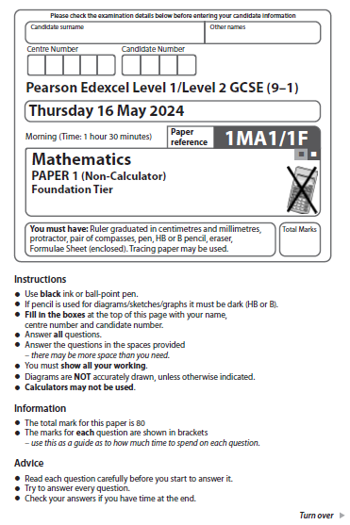
Answer ALL questions.
Write your answers in the spaces provided.
You must write down all the stages in your working.

1 Write the number 18 475 correct to the nearest thousand.
.......................................................
(Total for Question 1 is 1 mark)
___________________________________________________________________________

2 Write 0.3 as a percentage.
.......................................................%
(Total for Question 2 is 1 mark)
___________________________________________________________________________

3 Write down the mathematical name for the type of angle marked y.

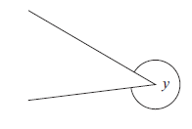
..................................................................................
(Total for Question 3 is 1 mark)
___________________________________________________________________________

4 Write these numbers in order of size.
Start with the smallest number.

0.21 | 0.2 | 0.03 | 0.1 | 0.16

......................................................................................................................................................
(Total for Question 4 is 1 mark)
___________________________________________________________________________

5 Find the square root of 64
.......................................................
(Total for Question 5 is 1 mark)
___________________________________________________________________________

1 Write the number 15 675 correct to the nearest thousand.

.......................................................
(Total for Question 1 is 1 mark)
___________________________________________________________________________

2 Write 0.7 as a percentage.

.......................................................%
(Total for Question 2 is 1 mark)
___________________________________________________________________________

3 Write down the mathematical name for the type of angle marked y.
y

..................................................................................
(Total for Question 3 is 1 mark)
___________________________________________________________________________

4 Write these numbers in order of size.
Start with the smallest number.

0.5 0.52 0.08 0.34 0.3

......................................................................................................................................................
(Total for Question 4 is 1 mark)
___________________________________________________________________________

5 Find the square root of 81

.......................................................
(Total for Question 5 is 1 mark)
___________________________________________________________________________

6 Ryan buys
4 cakes at £1.30 each
2 identical tins of soup.
Ryan pays with a £10 note.
He gets £1.80 change.
How much does Ryan pay for each tin of soup?

£.......................................................
(Total for Question 6 is 4 marks)

6 Josh buys

3 coffees at £2.60 each
2 identical pastries.

Josh pays with a £20 note.
He gets £2.20 change.

How much does Josh pay for each pastry?

£.......................................................
(Total for Question 6 is 4 marks)
___________________________________________________________________________
7 The table shows the number of hours that Lena and Pavel worked on each of four days
last week.

 | Wednesday | Thursday | Friday | Saturday
Lena | 6 | 9 | 8 | 6
Pavel | 7 | 6 | 5 | 6

On the grid, draw a suitable diagram or chart for this information.
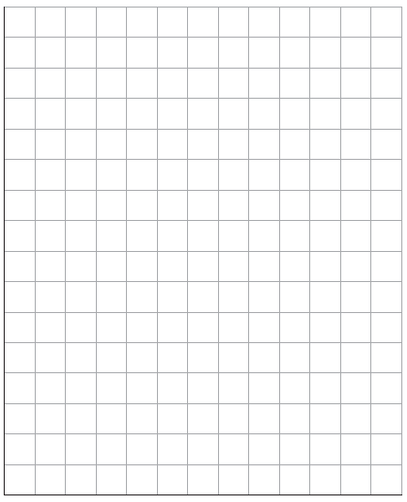

(Total for Question 7 is 4 marks)
___________________________________________________________________________
7 The table shows the number of hours that Leona and Petra studied on each of four days
last week.

 | Friday | Saturday | Sunday | Monday
Leona | 8 | 5 | 10 | 11
Petra | 13 | 8 | 9 | 9

On the grid, draw a suitable diagram or chart for this information.



(Total for Question 7 is 4 marks)
___________________________________________________________________________
8 OA, OB and OC are three straight lines.
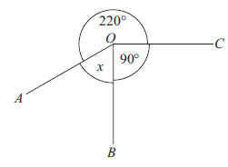
(i) Work out the size of the angle marked x.

.......................................................°
(2)
(ii) Give a reason for your answer.

......................................................................................................................................................

......................................................................................................................................................

......................................................................................................................................................
(1)
(Total for Question 8 is 3 marks)
___________________________________________________________________________

8 OA, OB and OC are three straight lines.

(i) Work out the size of the angle marked x.

90°
150°
x
A
C
B
O

.......................................................°
(2)

(ii) Give a reason for your answer.

......................................................................................................................................................

......................................................................................................................................................

......................................................................................................................................................
(1)
(Total for Question 8 is 3 marks)
___________________________________________________________________________

9 Here is a number machine.
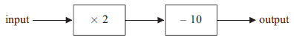
(a) Work out the output when the input is 13

.......................................................
(1)
(b) Work out the input when the output is 28

.......................................................
(2)
(c) Show that there is a number for which the output is the same as the input.

(2)
(Total for Question 9 is 5 marks)
___________________________________________________________________________

9 Here is a number machine.

× 3
– 12
input output

(a) Work out the output when the input is 15

.......................................................
(1)

(b) Work out the input when the output is 48

.......................................................
(2)

(c) Show that there is a number for which the input is the same as the output.

(2)
(Total for Question 9 is 5 marks)
___________________________________________________________________________

10 There are 24 cows and 36 sheep on a farm.
Write as a ratio the number of cows to the number of sheep.
Give your ratio in its simplest form.

.......................................................
(Total for Question 10 is 2 marks)

___________________________________________________________________________

10 There are 12 goats and 42 chickens on a farm.

Write as a ratio the number of goats to the number of chickens.
Give your ratio in its simplest form.

.......................................................
(Total for Question 10 is 2 marks)
___________________________________________________________________________

11 (a) Work out –12 ÷ –4

.......................................................
(1)
(b) Find the value of 2⁵

.......................................................
(1)
(c) Write one pair of brackets in this calculation so that the answer is correct.

30 ÷ 3 + 2 − 4 = 2
(1)
(Total for Question 11 is 3 marks)
___________________________________________________________________________

11 (a) Work out –20 ÷ –5

.......................................................
(1)

(b) Find the value of 3³

.......................................................
(1)

(c) Write one pair of brackets in this calculation so that the answer is correct.

30 ÷ 3 + 2 − 4 = 8

(1)
(Total for Question 11 is 3 marks)
___________________________________________________________________________

12 The diagram shows a triangle and a rectangle.
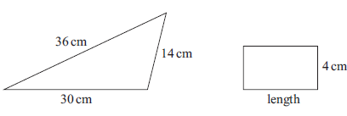
The perimeter of the rectangle is a quarter of the perimeter of the triangle.
Work out the length of the rectangle.

....................................................... cm
(Total for Question 12 is 4 marks)
___________________________________________________________________________

12 The diagram shows a triangle and a rectangle.

32 cm
12 cm 7 cm

length
28 cm

The perimeter of the rectangle is half the perimeter of the triangle.

Work out the length of the rectangle.

....................................................... cm
(Total for Question 12 is 4 marks)
___________________________________________________________________________

13 There are only £10 notes and £20 notes in a wallet.
Ali takes at random a note from the wallet.
(a) Write down the probability that Ali takes a note with a value of more than £5

.......................................................
(1)
There are only 1p coins and 2p coins in a bag.
The total value of the coins in the bag is 40p
The total value of the 1p coins is the same as the total value of the 2p coins.
Simon takes at random a coin from the bag.
(b) Find the probability that Simon takes a 1p coin.

.......................................................
(2)
(Total for Question 13 is 3 marks)
___________________________________________________________________________

13 There are an equal number of £10 notes and £20 notes in a wallet.

Rose takes at random a note from the wallet.

(a) Write down the probability that Rose takes a note with a value of more than £20

.......................................................
(1)

There are only 10p coins and 20p coins in a bag.
The total value of the coins in the bag is £6

The total value of the 10p coins is the same as the total value of the 20p coins.

Solly takes at random a coin from the bag.

(b) Find the probability that Solly takes a 20p coin.

.......................................................
(2)
(Total for Question 13 is 3 marks)
___________________________________________________________________________

14 Work out 273 × 54

.......................................................
(Total for Question 14 is 3 marks)
___________________________________________________________________________

14 Work out 374 × 56

.......................................................
(Total for Question 14 is 3 marks)

15 Tessa recorded the times that 15 adults took to complete a run.
She showed her results in a stem and leaf diagram.
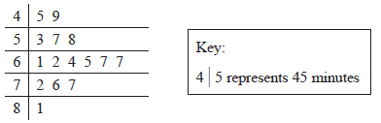
(a) Find the median.

....................................................... minutes
(1)
(b) Find the range.

....................................................... minutes
(2)
Tessa also recorded the times that 15 children took to complete the run.
For the children, the median was 75 minutes.
(c) Compare the times that the adults took with the times that the children took.

......................................................................................................................................................

......................................................................................................................................................

......................................................................................................................................................
(1)
(Total for Question 15 is 4 marks)
___________________________________________________________________________

15 Theresa recorded the ages of 15 people who visited the opera one evening.
She showed her results in a stem and leaf diagram.

3 | 5 | 9
4 | 3 | 7 | 8 |  |  |  |  | Key:  3 | 5 represents 35 years
5 | 1 | 2 | 4 | 5 | 7 | 7 |  | Key:  3 | 5 represents 35 years
6 | 2 | 6 | 7 |  |  |  |  | Key:  3 | 5 represents 35 years
7 | 1

(a) Find the median.

....................................................... years
(1)

(b) Find the range.

....................................................... years
(2)

Theresa also recorded the ages of 15 people who went to the cinema on the same evening.

For the people who visited the cinema, the median age was 32 years.

(c) Compare the ages of the people who went to the opera with the ages of the people who went to the cinema.

......................................................................................................................................................

......................................................................................................................................................

......................................................................................................................................................
(1)
(Total for Question 15 is 4 marks)
___________________________________________________________________________

16 Batteries are sold in packs of 4, in packs of 8 and in packs of 12
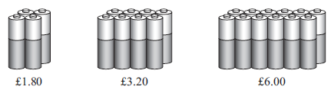
A pack of 4 batteries costs £1.80
A pack of 8 batteries costs £3.20
A pack of 12 batteries costs £6.00
Which pack gives the best value for money?
You must show how you get your answer.

(Total for Question 16 is 3 marks)
___________________________________________________________________________

16 Batteries are sold in packs of 4, in packs of 8 and in packs of 12

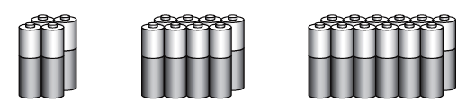
£2.20 £4.20 £6.20

A pack of 4 batteries costs £2.20
A pack of 8 batteries costs £4.20
A pack of 12 batteries costs £6.20

Which pack gives the best value for money?
You must show how you get your answer.

(Total for Question 16 is 3 marks)
___________________________________________________________________________

17 Solve 2(4x – 5) = 18

x = .......................................................
(Total for Question 17 is 3 marks)
___________________________________________________________________________

17 Solve 3(2x – 8) = 18

x = .......................................................
(Total for Question 17 is 3 marks)
___________________________________________________________________________

18 Write down the value of 10⁰

.......................................................
(Total for Question 18 is 1 mark)
___________________________________________________________________________

18 Write down the value of 2⁰

.......................................................
(Total for Question 18 is 1 mark)
___________________________________________________________________________

19
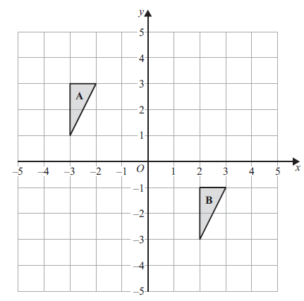
Describe fully the single transformation that maps triangle A onto triangle B.

......................................................................................................................................................

......................................................................................................................................................

......................................................................................................................................................

(Total for Question 19 is 2 marks)
___________________________________________________________________________

19
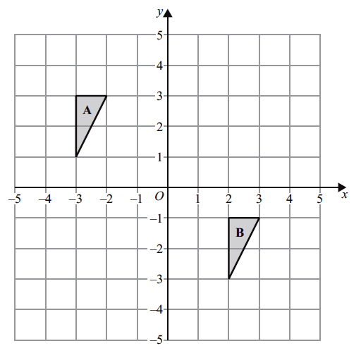

Describe fully the single transformation that maps triangle B onto triangle A.

......................................................................................................................................................

......................................................................................................................................................

......................................................................................................................................................
(Total for Question 19 is 2 marks)
___________________________________________________________________________

20 Here are the first four terms of an arithmetic sequence.

1 | 5 | 9 | 13

Find an expression, in terms of n, for the nth term of this sequence.

.......................................................
(Total for Question 20 is 2 marks)
___________________________________________________________________________

20 Here are the first four terms of an arithmetic sequence.

7 12 17 22

Find an expression, in terms of n, for the nth term of this sequence.

.......................................................
(Total for Question 20 is 2 marks)
___________________________________________________________________________

21 (a) Work out $3\frac{4}{5}-1\frac{2}{3}$

.......................................................
(2)
Kevin was asked to work out $2\frac{1}{3}×\frac{5}{8}$
Here is his working and his answer.
$$2\frac{1}{3}×\frac{5}{8}=\frac{7}{3}×\frac{5}{8}$$
$=\frac{35}{24}$
$=1\frac{9}{24}$
Kevin’s answer is wrong.

(b) What mistake has Kevin made?

......................................................................................................................................................

......................................................................................................................................................

......................................................................................................................................................(1)
(Total for Question 21 is 3 marks)
___________________________________________________________________________

21 (a) Work out 4 – 2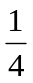

.......................................................
(2)

Kora was asked to work out 2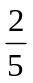 × 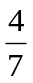

Here is her working and her answer.

2 × = 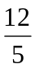×

= 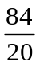

= 4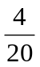

Kora’s answer is wrong.

(b) What mistake has Kora made?

......................................................................................................................................................

......................................................................................................................................................

......................................................................................................................................................
(1)
(Total for Question 21 is 3 marks)
___________________________________________________________________________

22 The diagram shows a plan of a floor.

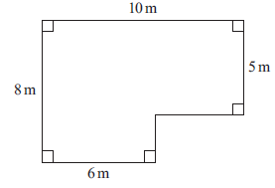

Petra is going to cover the floor with paint.
Petra has 3 tins of paint.
There are 2.5 litres of paint in each tin.
Petra thinks 1 litre of paint will cover 10 m² of floor.
(a) Assuming Petra is correct, does she have enough paint to cover the floor?
You must show all your working.

(4)

Actually, 1 litre of paint will cover 11 m² of floor.
(b) Does this affect your answer to part (a)?
You must give a reason for your answer.

......................................................................................................................................................

......................................................................................................................................................

......................................................................................................................................................(1)
(Total for Question 22 is 5 marks)
___________________________________________________________________________

22 The diagram shows a plan of a floor.

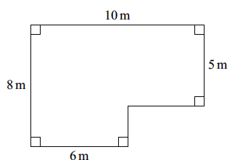

Peter is going to cover the floor with paint.

Peter has 4 tins of paint.
There are 1.5 litres of paint in each tin.

Peter thinks 1 litre of paint will cover 10 m² of floor.

(a) Assuming Peter is correct, does he have enough paint to cover the floor?
You must show all your working.

(4)
Actually, 1 litre of paint will cover 12 m² of floor.

(b) Does this affect your answer to part (a)?
You must give a reason for your answer.

......................................................................................................................................................

......................................................................................................................................................

......................................................................................................................................................
(1)
(Total for Question 22 is 5 marks)
___________________________________________________________________________

23 Here is a Venn diagram.

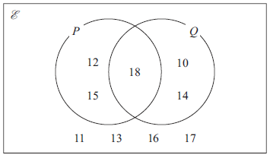

(a) Write down the numbers that are in set P′

.............................................................................................................
(1)
A number is chosen at random from the universal set, E
(b) Find the probability that this number is in the set P ∪ Q

.......................................................
(2)
(Total for Question 23 is 3 marks)
___________________________________________________________________________

23 Here is a Venn diagram.

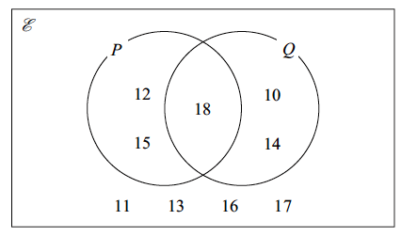

(a) Write down the numbers that are in set Q ′

.............................................................................................................
(1)

A number is chosen at random from the universal set,

(b) Find the probability that this number is in the set (P ∪ Q) ′

.......................................................
(2)
(Total for Question 23 is 3 marks)
___________________________________________________________________________

24 Sophie drives a distance of 513 kilometres on a motorway in France.
She pays 0.81 euros for every 10 kilometres she drives.
(a) Work out an estimate for the total amount that Sophie pays.

....................................................... euros
(3)
(b) Is your answer to part (a) an underestimate or an overestimate?
Give a reason for your answer.

......................................................................................................................................................

......................................................................................................................................................

......................................................................................................................................................
(1)
(Total for Question 24 is 4 marks)
___________________________________________________________________________

24 Stan drives a distance of 2043 kilometres on motorways in Germany.
He pays 0.92 euros for every 100 kilometres he drives.

(a) Work out an estimate for the total amount that Stan pays.

....................................................... euros
(3)

(b) Is your answer to part (a) an underestimate or an overestimate?
Give a reason for your answer.

......................................................................................................................................................

......................................................................................................................................................

......................................................................................................................................................
(1)
(Total for Question 24 is 4 marks)
___________________________________________________________________________

25 Here is a straight line L drawn on a grid.

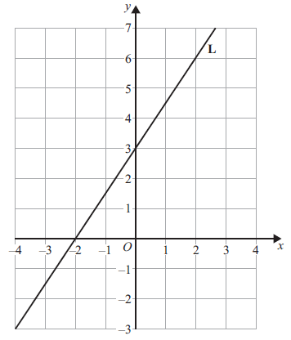

(a) Find an equation for L.
..................................................................................
(3)
M is a different straight line with equation y = 5x
(b) Write down the equation of a straight line parallel to M.

..................................................................................
(1)
(Total for Question 25 is 4 marks)
___________________________________________________________________________

25 Here is a straight line L drawn on a grid.

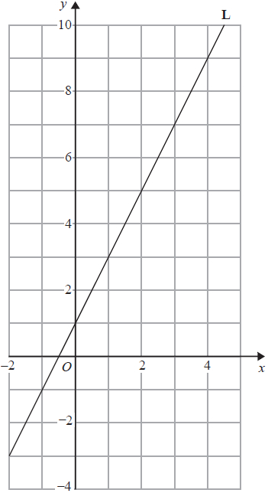

(a) Find an equation for L.

..................................................................................
(3)

M is a different straight line with equation y = 3x

(b) Write down the equation of a straight line parallel to M.

..................................................................................
(1)
(Total for Question 25 is 4 marks)
___________________________________________________________________________
26 Kasim has some small jars, some medium jars and some large jars.
He has a total of 400 jars.
$\frac{3}{8}$ of the 400 jars are empty.
For the empty jars,
number of small jars : number of medium jars = 3 : 4
number of medium jars : number of large jars = 1 : 2
Work out the percentage of Kasim’s jars that are empty small jars.

.......................................................%
(Total for Question 26 is 5 marks)
___________________________________________________________________________

26 Keisha has some small bottles, some medium bottles and some large bottles.
She has a total of 600 bottles.

of the 600 bottles are green.

For the green bottles,

number of small bottles : number of medium bottles = 4 : 3
number of medium bottles : number of large bottles = 3 : 5

Work out the percentage of Keisha’s bottles that are medium green bottles.

.......................................................%
(Total for Question 26 is 5 marks)
___________________________________________________________________________

27 In a sale, normal prices are reduced by 30%
The sale price of a TV is £280
Work out the normal price of the TV.

£.......................................................
(Total for Question 27 is 2 marks)
___________________________________________________________________________

27 In a sale, normal prices are reduced by 25%

The sale price of a games console is £225

Work out the normal price of the games console.

£.......................................................
(Total for Question 27 is 2 marks)
___________________________________________________________________________

28 Solve x + 11 ≤ 5 – 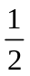x

.......................................................
(Total for Question 28 is 3 marks)
28 Solve x + 12 ≤ 2 – 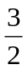x

.......................................................
(Total for Question 28 is 3 marks)
___________________________________________________________________________

TOTAL FOR PAPER IS 80 MARKS

