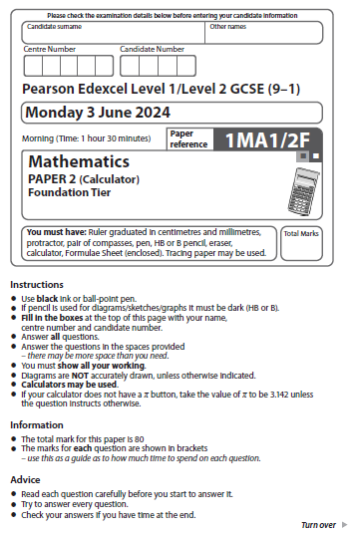
Answer ALL questions.
Write your answers in the spaces provided.
You must write down all the stages in your working.

1 Write the following numbers in order.
Start with the lowest number.

4 | –3 | 7 | 2 | –1

............................................................................................................
(Total for Question 1 is 1 mark)
___________________________________________________________________________

2 Change 5000 millilitres to litres.

........................... litres
(Total for Question 2 is 1 mark)
___________________________________________________________________________

3 Write 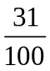 as a decimal.
......................................................
(Total for Question 3 is 1 mark)
___________________________________________________________________________

4 Write down the multiple of 7 that is between 30 and 40

......................................................
(Total for Question 4 is 1 mark)
___________________________________________________________________________

5 Complete the statement below to make it correct.

........................... × m = 2m
(Total for Question 5 is 1 mark)
___________________________________________________________________________

1 Write the following numbers in order.
Start with the lowest number.

5 –7 2 8 –9

............................................................................................................
(Total for Question 1 is 1 mark)
___________________________________________________________________________

2 Change 9000 millilitres to litres.

........................... litres
(Total for Question 2 is 1 mark)
___________________________________________________________________________

3 Write 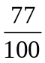 as a decimal.

......................................................
(Total for Question 3 is 1 mark)
___________________________________________________________________________

4 Write down the multiple of 9 that is between 60 and 70

......................................................
(Total for Question 4 is 1 mark)
___________________________________________________________________________

5 Complete the statement below to make it correct.

........................... × n = 4n
(Total for Question 5 is 1 mark)
___________________________________________________________________________

6 Ben sells houses.
The pictogram shows information about the number of houses Ben sold in each of the
first three months of last year.

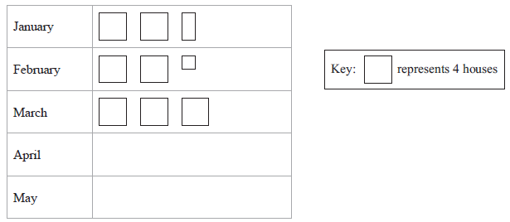

(a) Write down the number of houses Ben sold in January.

......................................................
(1)
In April, Ben sold 11 houses.
(b) Show this information on the pictogram.
(1)
Ben sold a total of 60 houses in the first five months of last year.
(c) Work out the number of houses Ben sold in May.

......................................................
(3)
(Total for Question 6 is 5 marks)
___________________________________________________________________________

6 Harry sells cars.

The pictogram shows information about the number of cars Harry sold in each of the
first three months of last year.

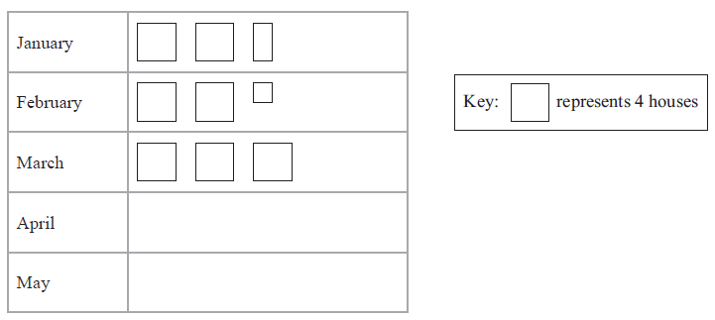

(a) Write down the number of cars Harry sold in February.

......................................................
(1)

In April, Harry sold 13 cars.

(b) Show this information on the pictogram.
(1)

Harry sold a total of 70 cars in the first five months of last year.

(c) Work out the number of cars Harry sold in May.

......................................................
(3)
(Total for Question 6 is 5 marks)

7 (a) Measure the length of this line.
Give your answer in centimetres.

...................................................... centimetres
(1)
(b) Measure the size of the angle marked x.

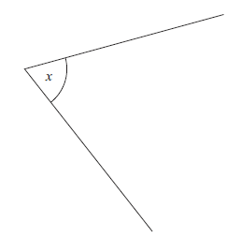

...........................°
(1)
(c) In the space below, draw a hexagon.
(1)

(Total for Question 7 is 3 marks)
___________________________________________________________________________

7 (a) Measure the length of this line.
Give your answer in centimetres.

_____________________________________

...................................................... centimetres
(1)

(b) Measure the size of the angle marked x.

x

........................... °
(1)

(c) In the space below, draw a pentagon.

(1)
(Total for Question 7 is 3 marks)

8 The points A and B are shown on the grid.

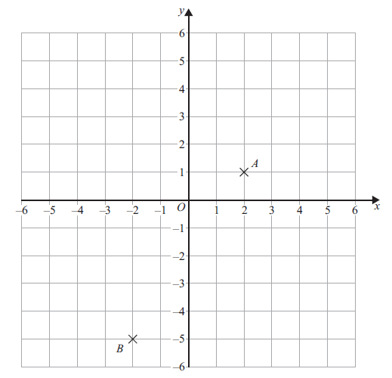

(a) Write down the coordinates of the point A.
(............................ , ............................)
(1)
(b) Find the coordinates of the midpoint of AB.
(............................ , ............................)
(2)
(c) On the grid, mark with a cross (×) the point with coordinates (– 4, 2)
Label this point C.
(1)
(Total for Question 8 is 4 marks)
___________________________________________________________________________

8 The points A and B are shown on the grid.

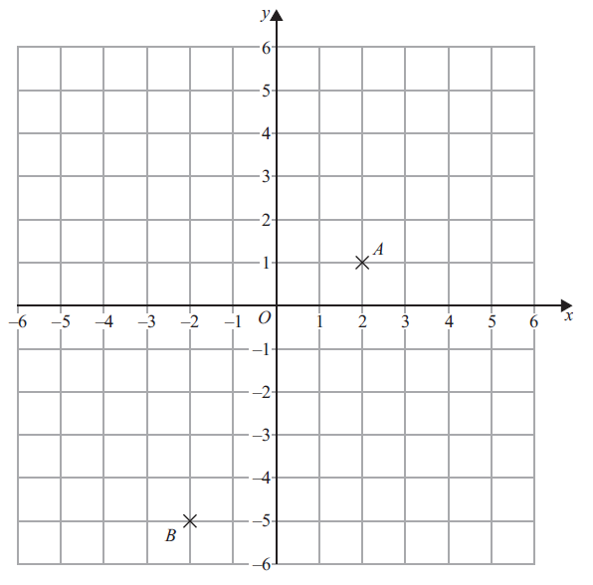

(a) Write down the coordinates of the point A.

(............................ , ............................)
(1)

(b) Find the coordinates of the midpoint of AB.

(............................ , ............................)
(2)

(c) On the grid, mark with a cross (×) the point with coordinates (4, –2)
Label this point C.

(1)
(Total for Question 8 is 4 marks)

9 Anil has a job as a driver.
He is paid for each mile he drives.
He is also paid expenses.

One week Anil writes down the distance readings from his car.

Start of week: | 4 | 7 | 2 | 4 | 1 | miles
End of week: | 4 | 7 | 8 | 7 | 9 | miles

For this week, Anil is paid 47p for each mile he drives.
He is also paid expenses of £80

Work out the total amount that Anil is paid.
Give your answer in pounds.

......................................................
(Total for Question 9 is 4 marks)

___________________________________________________________________________

9 Alan has a job as a driver.
He is paid for each kilometre he drives.
He is also paid expenses.

One week Alan writes down the distance readings from his car.

Start of week: | 5 | 8 | 1 | 3 | 6 | km
End of week: | 5 | 8 | 5 | 2 | 8 | km

For this week, Alan is paid 53p for each mile he drives.
He is also paid expenses of £90

Work out the total amount that Alan is paid.
Give your answer in pounds.

£......................................................
(Total for Question 9 is 4 marks)
___________________________________________________________________________

10 Anita throws a coin 3 times.
Each time the coin can land on heads (H) or tails (T).
List all the possible outcomes.

......................................................................................................................................................

......................................................................................................................................................

......................................................................................................................................................
(Total for Question 10 is 2 marks)
___________________________________________________________________________

10 Anja throws a two-sided counter 3 times.
Each time the counter can land on green (G) or blue (B).

List all the possible outcomes.

......................................................................................................................................................

......................................................................................................................................................

......................................................................................................................................................
(Total for Question 10 is 2 marks)
___________________________________________________________________________

11 Majid has a spinner.
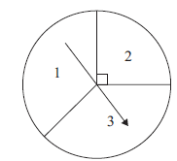
Majid is going to spin the arrow.
The arrow can land on 1 or on 2 or on 3
Majid says,
“The probability that the arrow will land on 2 is because the spinner has
three sections.”
Is Majid correct?
You must give a reason for your answer.

......................................................................................................................................................

......................................................................................................................................................

......................................................................................................................................................
(Total for Question 11 is 1 mark)
___________________________________________________________________________

11 Dominic has a spinner.

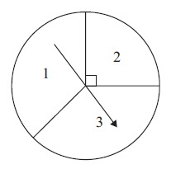

Dominic is going to spin the arrow.
The arrow can land on 1 or on 2 or on 3

Dominic says,

“The probability that the arrow will land on 3 is 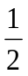 because the spinner has two equal sections.”

Is Dominic correct?
You must give a reason for your answer.

......................................................................................................................................................

......................................................................................................................................................

......................................................................................................................................................
(Total for Question 11 is 1 mark)
___________________________________________________________________________

12 Saira buys 24 bars of chocolate.
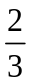 of the 24 bars are white chocolate.
The rest of the 24 bars are milk chocolate.
Each milk chocolate bar has a weight of 35 grams.
Work out the total weight of the milk chocolate bars that Saira buys.

...................................................... grams
(Total for Question 12 is 3 marks)
___________________________________________________________________________

12 Nila buys 36 pints of milk.
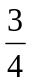 of the 36 pints are soya milk.
The rest of the 36 pints are oat milk.

Each pint of oat milk has a weight of 90 grams.

Work out the total weight of the pints of oat milk that Nila buys.

...................................................... grams
(Total for Question 12 is 3 marks)
___________________________________________________________________________

13 (a) Simplify 2c × 3d

......................................................
(1)
T = x + 2y
x = 3 and y = – 4
(b) Work out the value of T.

T = ......................................................
(2)
(Total for Question 13 is 3 marks)
___________________________________________________________________________

13 (a) Simplify 3c × 4d

......................................................
(1)
S = 3x + 2y
x = 2 and y = –3

(b) Work out the value of S.

T = ......................................................
(2)
(Total for Question 13 is 3 marks)
___________________________________________________________________________

14 On Monday, Lizzie cycled 36 kilometres in 3 hours.
(a) Work out Lizzie’s average speed.

...................................................... kilometres per hour
(2)
On Tuesday, Lizzie cycled 36 kilometres at an average speed of 16 kilometres per hour.
Lizzie says that the total time she cycled on Monday and Tuesday was less than
5 hours 20 minutes.
(b) Is Lizzie correct?
You must show how you get your answer.

(3)
(Total for Question 14 is 5 marks)

___________________________________________________________________________

14 On Monday, Landon cycled 56 kilometres in 4 hours.

(a) Work out Landon’s average speed.

...................................................... kilometres per hour
(2)

On Tuesday, Landon cycled 56 kilometres at an average speed of 16 kilometres per hour.

Landon says that the total time he cycled on Monday and Tuesday was less than
7 hours 20 minutes.

(b) Is Landon correct?
You must show how you get your answer.

(3)
(Total for Question 14 is 5 marks)
___________________________________________________________________________
15 £3500 is invested in a bank for 6 years.
The bank pays simple interest at a rate of 2.5% per year.
Work out the total amount of simple interest paid.

£......................................................
(Total for Question 15 is 2 marks)
___________________________________________________________________________

15 £4500 is invested in a bank for 5 years.
The bank pays simple interest at a rate of 3.5% per year.

Work out the total amount of simple interest paid.

£......................................................
(Total for Question 15 is 2 marks)
___________________________________________________________________________

16 You can use this graph to change between ounces and grams.

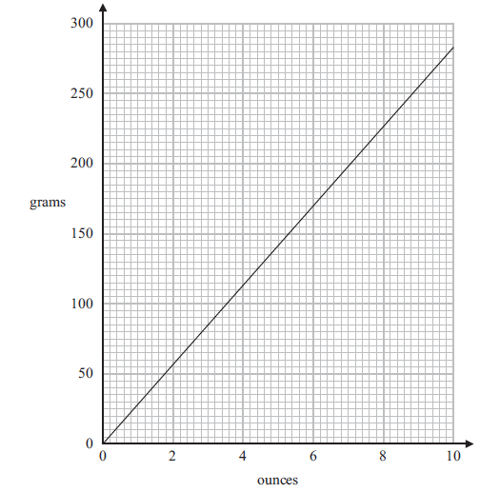

(a) Change 6 ounces to grams.

...................................................... grams
(1)
(b) Change 1 kg to ounces.

...................................................... ounces
(2)
(Total for Question 16 is 3 marks)
___________________________________________________________________________

16 You can use this graph to change between ounces and grams.

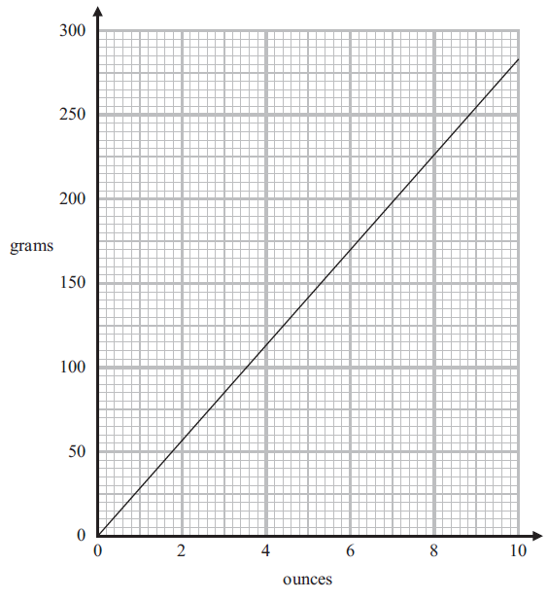

(a) Change 5 ounces to grams.

...................................................... grams
(1)
(b) Change 2 kg to ounces.

...................................................... ounces
(2)
(Total for Question 16 is 3 marks)
___________________________________________________________________________

17 Here is a triangle ABC.

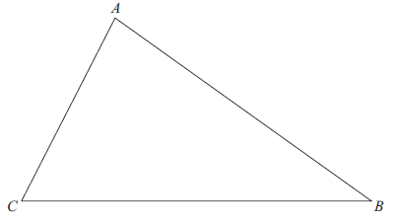

The region R consists of all points inside the triangle that are
less than 4 cm from A
and closer to C than to B.
On the diagram show, by shading, the region R.
(Total for Question 17 is 3 marks)
___________________________________________________________________________

17 Here is a triangle ABC.
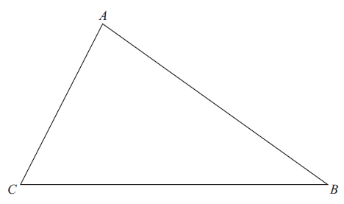

The region R consists of all points inside the triangle that are

less than 3 cm from A
and closer to B than to C.

On the diagram show, by shading, the region R.
(Total for Question 17 is 3 marks)
___________________________________________________________________________

18 Mrs Simpson organised a school trip for 66 children.
The total cost of the trip was £1800
The school paid 56% of the total cost.
The rest of the total cost was divided equally between the 66 children.
Work out how much money each child paid.

£......................................................
(Total for Question 18 is 3 marks)

___________________________________________________________________________

18 Mr Weaver organised a skiing trip for 35 students.

The total cost of the trip was £24 500
The college paid 40% of the total cost.
The rest of the total cost was divided equally between the 35 students.

Work out how much money each student paid.

£......................................................
(Total for Question 18 is 3 marks)
___________________________________________________________________________

19 (a) Work out the value of $\frac{\sqrt{35.2+{1.7}^{3}}}{{4.6}^{2}-8.91}$
Write down all the numbers on your calculator display.

............................................................................................................
(2)
(b) Write your answer to part (a) correct to 2 significant figures.

......................................................
(1)
(Total for Question 19 is 3 marks)

19 (a) Work out the value of 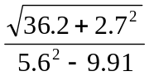
Write down all the numbers on your calculator display.

....................................................................
(2)

(b) Write your answer to part (a) correct to 2 significant figures.

......................................................
(1)
(Total for Question 19 is 3 marks)
___________________________________________________________________________

20 ABC is a right-angled triangle.
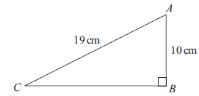

Work out the length of CB.
Give your answer correct to 3 significant figures.

...................................................... cm
(Total for Question 20 is 2 marks)
___________________________________________________________________________

20 ABC is a right-angled triangle.
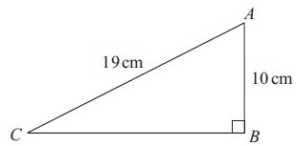

15 cm
18 cm

Work out the length of AB.
Give your answer correct to 3 significant figures.

...................................................... cm
(Total for Question 20 is 2 marks)
___________________________________________________________________________

21 (a) Write 90 as a product of its prime factors.

......................................................
(2)
A = 2² × 3
B = 2 × 3²
(b) Write down the lowest common multiple (LCM) of A and B.

......................................................
(1)
(Total for Question 21 is 3 marks)
___________________________________________________________________________

21 (a) Write 60 as a product of its prime factors.

......................................................
(2)

A = 2³ × 3²
B = 2 × 3³

(b) Write down the lowest common multiple (LCM) of A and B.

......................................................
(1)
(Total for Question 21 is 3 marks)
___________________________________________________________________________

22 The number of hours, H, that some machines take to make 5000 bottles is given by

H = $\frac{72}{n}$ where $n$ is the number of machines.
On Monday, 6 machines made 5000 bottles.
On Tuesday, 9 machines made 5000 bottles.
The machines took more time to make the bottles on Monday than on Tuesday.
How much more time?

........................... hours
(Total for Question 22 is 2 marks)
___________________________________________________________________________

22 The number of hours, H, that some machines take to make 8000 widgets is given by

H = 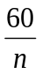 where n is the number of machines.

On Monday, 15 machines made 8000 widgets.
On Tuesday, 10 machines made 8000 widgets.

The machines took more time to make the widgets on Tuesday than on Monday.

How much more time?

........................... hours
(Total for Question 22 is 2 marks)
___________________________________________________________________________

23 There are only red discs, blue discs and yellow discs in a bag.
There are 24 yellow discs in the bag.
Mel is going to take at random a disc from the bag.
The probability that the disc will be yellow is 0.16
the number of red discs : the number of blue discs = 5 : 4
Work out the number of red discs in the bag.

......................................................
(Total for Question 23 is 4 marks)
___________________________________________________________________________

23 There are only red sweets, orange sweets and yellow sweets in a jar.
There are 36 orange sweets in the jar.

Hannah is going to take at random a sweet from the jar.

The probability that the sweet will be orange is 0.18

the number of red sweets : the number of yellow sweets = 1 : 3

Work out the number of yellow sweets in the jar.

......................................................
(Total for Question 23 is 4 marks)
___________________________________________________________________________

24 (a) Complete the table of values for y = x² – x

x | –2 | –1 | 0 | 1 | 2 | 3
y | 6 |  | 0 |  | 2
(2)
(b) On the grid, draw the graph of y = x² – x for values of x from –2 to 3
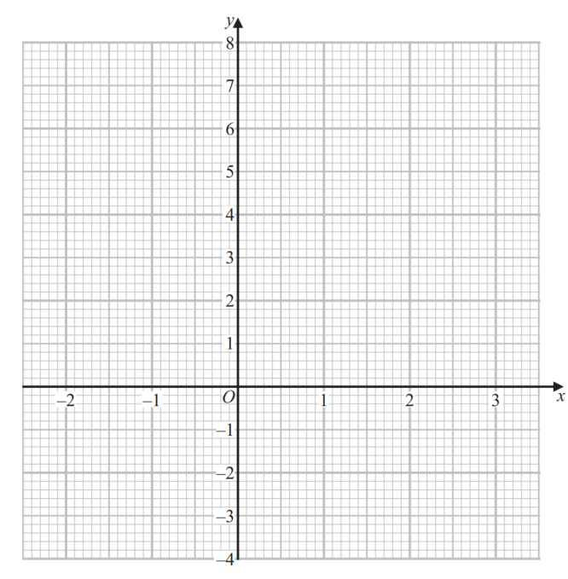
(2)
(c) Use your graph to find estimates for the solutions of the equation x² – x = 4

............................................................................................................
(2)
(Total for Question 24 is 6 marks)
___________________________________________________________________________

24 (a) Complete the table of values for y = x² – 2x

x | –2 | –1 | 0 | 1 | 2 | 3
y | 8 |  | 0 |  | 0

(2)

(b) On the grid, draw the graph of y = x² – 2x for values of x from –2 to 3
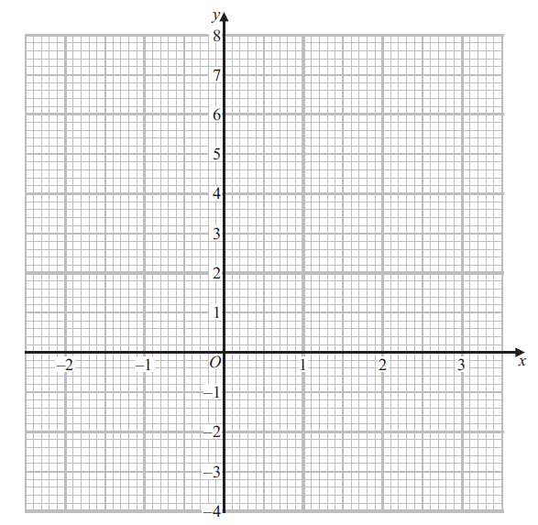 (2)

(c) Use your graph to find estimates for the solutions of the equation x² – 2x = 2

...............................................................
(2)
(Total for Question 24 is 6 marks)
___________________________________________________________________________

25 Andy, Luke and Tina share some sweets in the ratio 1 : 6 : 14
Tina gives $\frac{3}{7}$ of her sweets to Andy.
Tina then gives $12\frac{1}{2}$ % of the rest of her sweets to Luke.
Tina says,
“Now all three of us have the same number of sweets.”
Is Tina correct?
You must show how you get your answer.

(Total for Question 25 is 4 marks)
___________________________________________________________________________

25 Aaron, Lucy and Tom share some money in the ratio 4 : 9 : 14
Tom gives 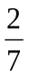 of his money to Aaron.
Tom then gives 10% of the rest of his money to Lucy.

Tom says,

“Now all three of us have the same amount of money.”

Is Tom correct?
You must show how you get your answer.

(Total for Question 25 is 4 marks)
___________________________________________________________________________

26 ABCD is a quadrilateral.

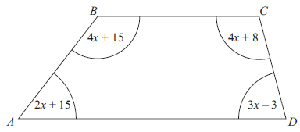
All angles are measured in degrees.
Show that ABCD is a trapezium.

(Total for Question 26 is 4 marks)
___________________________________________________________________________

26 ABCD is a quadrilateral.

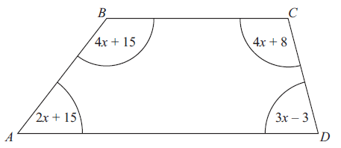
4x + 30
3x – 11
5x + 4
3x – 8
A
B
C
D

All angles are measured in degrees.

Show that ABCD is a trapezium.

(Total for Question 26 is 4 marks)
___________________________________________________________________________
27 ABC and DEF are two similar isosceles triangles.
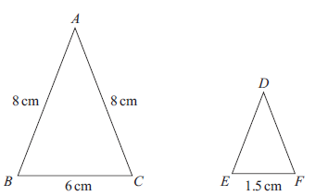
DE = DF
Work out the length of DE.

...................................................... cm
(Total for Question 27 is 2 marks)
___________________________________________________________________________

27 ABC and DEF are two similar isosceles triangles.

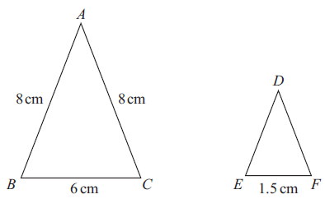
10 cm
2 cm
12 cm
12 cm

DE = DF

Work out the length of DE.

...................................................... cm
(Total for Question 27 is 2 marks)
___________________________________________________________________________

28 The table shows information about the weights of 120 oranges.

Weight (w grams) | Frequency
50 < w ≤ 100 | 34
100 < w ≤ 150 | 29
150 < w ≤ 200 | 27
200 < w ≤ 250 | 19
250 < w ≤ 300 | 11

(a) Find the class interval that contains the median.

.................................................................................
(1)
(b) Calculate an estimate for the mean weight of the 120 oranges.
Give your answer correct to 3 significant figures.

...................................................... grams
(3)
(Total for Question 28 is 4 marks)

28 The table shows information about the weights of 240 potatoes.

Weight (w grams) | Frequency
50 < w ≤ 100 | 50
100 < w ≤ 150 | 55
150 < w ≤ 200 | 53
200 < w ≤ 250 | 45
250 < w ≤ 300 | 37

(a) Find the class interval that contains the median.

.................................................................
(1)

(b) Calculate an estimate for the mean weight of the 240 potatoes.
Give your answer correct to 3 significant figures.

...................................................... grams
(3)
(Total for Question 28 is 4 marks)
___________________________________________________________________________
TOTAL FOR PAPER IS 80 MARKS

