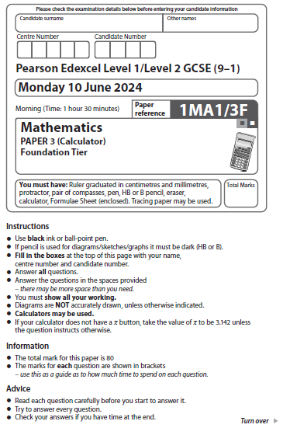

Answer ALL questions.
Write your answers in the spaces provided.
You must write down all the stages in your working.

1 Write 23% as a fraction.

......................................................
(Total for Question 1 is 1 mark)
___________________________________________________________________________

2 Change 800 centimetres to metres.

...................................................... metres
(Total for Question 2 is 1 mark)
___________________________________________________________________________

3 Write down the value of the 3 in the number 62 837

......................................................
(Total for Question 3 is 1 mark)
___________________________________________________________________________

4 Simplify 7a + a – 5a
......................................................
(Total for Question 4 is 1 mark)
___________________________________________________________________________

5 Write the following fractions in order of size.
Start with the smallest fraction.

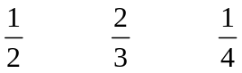
............................................................................................................
(Total for Question 5 is 1 mark)
___________________________________________________________________________

1 Write 73% as a fraction.

......................................................
(Total for Question 1 is 1 mark)
___________________________________________________________________________

2 Change 8 metres to centimetres.

...................................................... centimetres
(Total for Question 2 is 1 mark)
___________________________________________________________________________

3 Write down the value of the 8 in the number 62 837

......................................................
(Total for Question 3 is 1 mark)
___________________________________________________________________________

4 Simplify 3c – c + 7c

......................................................
(Total for Question 4 is 1 mark)
___________________________________________________________________________

5 Write the following fractions in order of size.
Start with the smallest fraction.

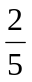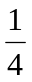

............................................................................................................
(Total for Question 5 is 1 mark)
___________________________________________________________________________

6 A map has a scale of 1 cm represents 4 km.
On the map, the distance from town A to town B is 8 cm.
(a) Work out the real distance, in km, from town A to town B.

.

..................................................... km
(2)
The real length of a road is 10 km.
(b) Work out the length of the road on the map.
Give the units of your answer.

.................................................................................
(2)
(Total for Question 6 is 4 marks)
___________________________________________________________________________

6 A map has a scale of 1 cm represents 6 km.

On the map, the distance from city A to city B is 18 cm.

(a) Work out the real distance, in km, from city A to city B.

...................................................... km
(2)

The real length of a river is 24 km.

(b) Work out the length of the river on the map.
Give the units of your answer.

.................................................................................
(2)
(Total for Question 6 is 4 marks)
___________________________________________________________________________

7 Julie asks some students how they travel to school.
The chart shows her results.
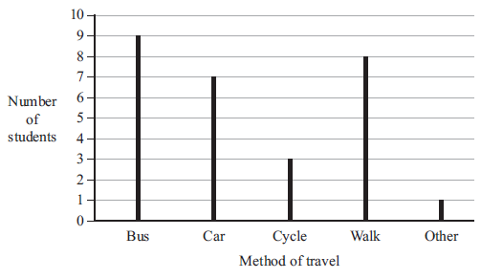
(a) Write down which method of travel is the mode.

......................................................
(1)
More students walk to school than cycle to school.
(b) How many more?

......................................................
(1)
(Total for Question 7 is 2 marks)
___________________________________________________________________________

7 Jayne asks some students how they travel to school.
The chart shows her results.

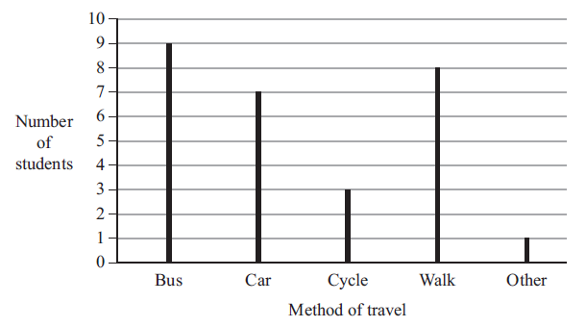

(a) Write down which method of travel is the most popular.

......................................................
(1)
More students take the bus to school than cycle to school.

(b) How many more?

......................................................
(1)
(Total for Question 7 is 2 marks)
___________________________________________________________________________

8 Aisha was born in 1993
There was an election in the year of Aisha’s 18th birthday.
There is an election every 5 years.
Will there be an election in 2030?
You must show how you get your answer.

(Total for Question 8 is 3 marks)
___________________________________________________________________________

8 Alana was born in 1997

There was an election in the year of Alana’s 18th birthday.

There is an election every 5 years.

Will there be an election in 2030?
You must show how you get your answer.

(Total for Question 8 is 3 marks)

9 Lucia is going on a skiing holiday.
The cost of ski hire is £26 per day.
The cost of a lift pass is £45 per day.
The cost of ski lessons is £23.50 per hour.
Lucia will pay for
ski hire for 5 days
a lift pass for 4 days
ski lessons for 8 hours.
Lucia has £500
Show that Lucia has enough money to pay for the total cost of ski hire, the lift pass and
the ski lessons.

(Total for Question 9 is 3 marks)
___________________________________________________________________________

9 Lucy is going on a mountain hiking holiday.

The cost of a mountain guide is £28 per day.
The cost of accommodation is £55 per day.
The cost of GPS tracking is £1.50 per hour.

Lucy will pay for
a mountain guide for 5 days
accommodation for 6 days
GPS tracking for 32 hours.

Lucy has £550

Show that Lucy has enough money to pay for the total cost of the tour guide, accommodation and the GPS tracking.

(Total for Question 9 is 3 marks)

10 Here is a circle.

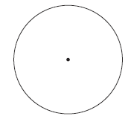

(a) On the diagram above, draw a radius of the circle.
(1)
Here is another circle.

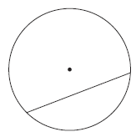

(b) Write down the mathematical name for the straight line inside this circle.

......................................................
(1)
(Total for Question 10 is 2 marks)
___________________________________________________________________________

10 Here is a circle.

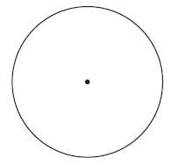

(a) On the diagram above, draw a diameter of the circle.
(1)

Here is another circle.

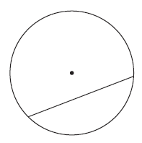

(b) Write down the mathematical name for the straight line inside this circle.

......................................................
(1)
(Total for Question 10 is 2 marks)
___________________________________________________________________________

11 There are 8 episodes in a TV series.
Each episode lasts 45 minutes.
Work out the total time that the 8 episodes last.
Give your answer in hours.

...................................................... hours
(Total for Question 11 is 2 marks)
___________________________________________________________________________

11 There are 6 episodes in a radio series.
Each episode lasts 40 minutes.

Work out the total time that the 6 episodes last.
Give your answer in hours.

...................................................... hours
(Total for Question 11 is 2 marks)
___________________________________________________________________________

12 Write down three prime numbers that are between 20 and 40

......................................... , ......................................... , .........................................
(Total for Question 12 is 2 marks)
___________________________________________________________________________

12 Write down three prime numbers that are between 30 and 50

.................................... , .................................... , ....................................
(Total for Question 12 is 2 marks)
___________________________________________________________________________

13 James asks students in Year 10 and Year 11 to name their favourite language from
French or German or Spanish.
The two‑way table shows information about his results.

 | French | German | Spanish | Total
Year 10 | 33 |  | 34
Year 11 |  | 45 |  | 113
Total |  |  | 67 | 207

Complete the two‑way table.

(Total for Question 13 is 3 marks)
___________________________________________________________________________

13 Joel asks students in Year 8 and Year 9 to name their favourite fruit from apple,
orange or banana.

The two-way table shows information about his results.

 | Apple | Orange | Banana | Total
Year 8 | 46 |  | 52
Year 9 |  | 67 |  | 125
Total |  |  | 89 | 256

Complete the two-way table.

(Total for Question 13 is 3 marks)
___________________________________________________________________________
14 The table gives information about the drinks people ordered in a cafe.

Drink | Number of people
Coffee | 30
Hot chocolate | 10
Tea | 50

Draw an accurate pie chart for this information.

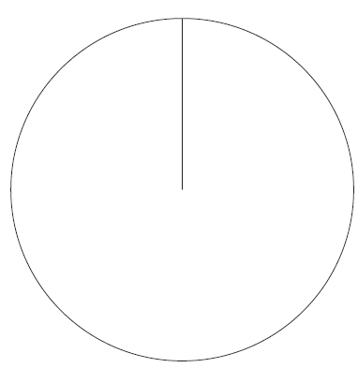

(Total for Question 14 is 3 marks)
__________________________________________________________________________
14 The table gives information about the sandwiches people ordered in a cafe.

Sandwich | Number of people
Egg | 35
Chicken | 45
Ham | 10

Draw an accurate pie chart for this information.

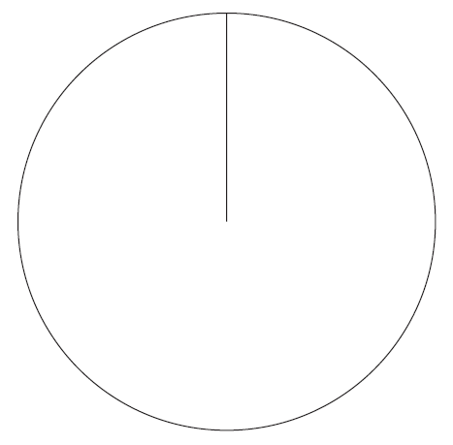

(Total for Question 14 is 3 marks)

___________________________________________________________________________

15 Which is greater
15% of 88 or 20% of 62?
You must show all your working.

(Total for Question 15 is 3 marks)
___________________________________________________________________________

15 Which is greater
15% of 108 or 30% of 58?

You must show all your working.

(Total for Question 15 is 3 marks)
___________________________________________________________________________

16 (a) Simplify m × m × m × m

......................................................
(1)
In a competition, a player gets
5 points for each game they win
2 points for each game they draw
0 points for each game they lose.
Amy wins x games and draws y games.
(b) Write down an expression, in terms of x and y, for the total number of points
Amy gets.

..................................................................................
(2)
(Total for Question 16 is 3 marks)
___________________________________________________________________________

16 (a) Simplify m × m × m × m × m × m

......................................................
(1)

In a competition, a player gets

3 points for each game they win
1 points for each game they draw
0 points for each game they lose.

Anja wins p games and draws q games.

(b) Write down an expression, in terms of p and q, for the total number of points Anja gets.

............................................................
(2)
(Total for Question 16 is 3 marks)
___________________________________________________________________________

17 Here are the ingredients needed to make 20 shortbread biscuits.
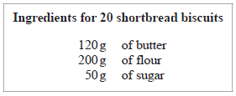
Heidi wants to make 30 shortbread biscuits.
How much of each ingredient will Heidi need?

butter ...................................................... g

flour ...................................................... g

sugar ...................................................... g
(Total for Question 17 is 3 marks)
___________________________________________________________________________

17 Here are the ingredients needed to make 30 shortbread biscuits.

Ingredients for 30 shortbread biscuits
180g of butter
300g of flour
75g of sugar

Harry wants to make 45 shortbread biscuits.

How much of each ingredient will Harry need?

butter ...................................................... g

flour ...................................................... g

sugar ...................................................... g
(Total for Question 17 is 3 marks)
___________________________________________________________________________

18
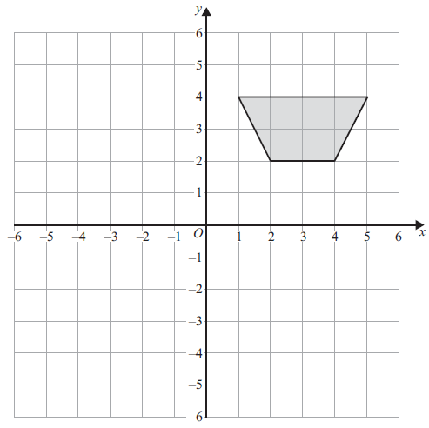

(a) On the grid above, rotate the shaded shape 180° about (0, 0)
(2)

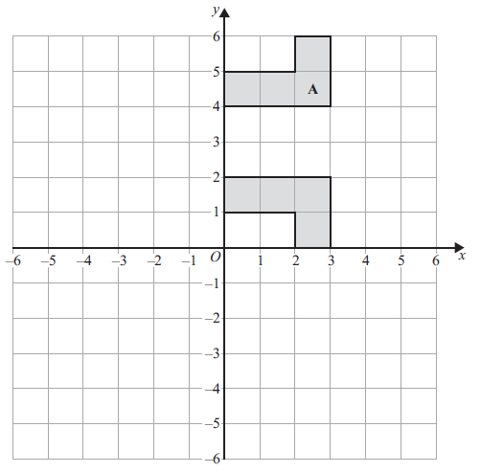
Mike was asked to

‘Reflect shape A in the line with equation x = 3’

Mike’s answer is shown on the grid.
His answer is wrong.
(b) Explain why.

......................................................................................................................................................

......................................................................................................................................................

......................................................................................................................................................
(1)
(Total for Question 18 is 3 marks)
___________________________________________________________________________

18
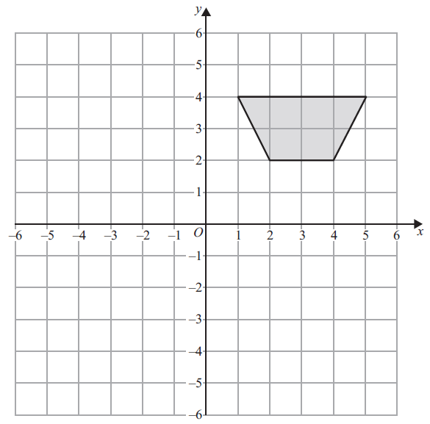

(a) On the grid above, rotate the shaded shape clockwise 90° about (0, 0)
(2)
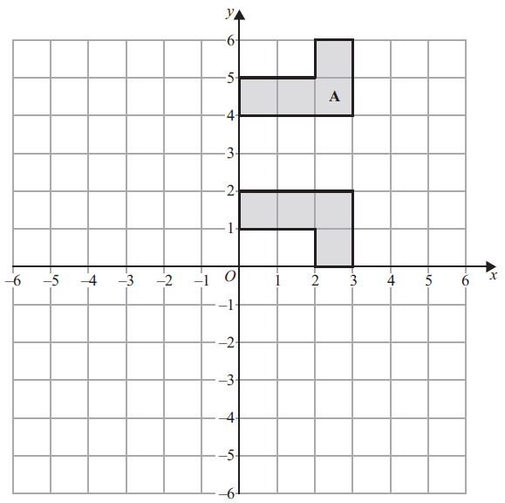

Myria was asked to

‘Reflect shape A in the line with equation y = 0’

Myria’s answer is shown on the grid.
Her answer is wrong.

(b) Explain why.

...............................................................................................................................................

...............................................................................................................................................

...............................................................................................................................................
(1)
(Total for Question 18 is 3 marks)

19 On the grid below, draw the graph of y = 3x – 2 for values of x from –2 to 3

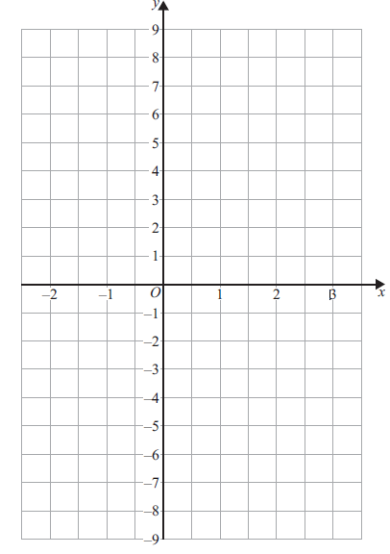
(Total for Question 19 is 3 marks)
___________________________________________________________________________

19 On the grid below, draw the graph of y = 4x – 1 for values of x from –1 to 2

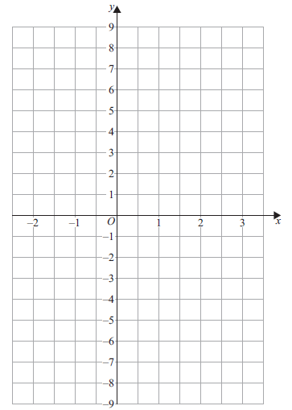

(Total for Question 19 is 3 marks)
___________________________________________________________________________

20 ABC and BCD are isosceles triangles.
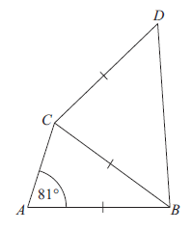
AB = BC = CD
Angle CAB = 81°
Angle BCD = 4 × angle ABC
Find
the size of angle ABC : the size of angle CBD
Give your answer in the form 1 : n
You must show all your working.

......................................................
(Total for Question 20 is 5 marks)
___________________________________________________________________________

20 ABC and BCD are isosceles triangles.
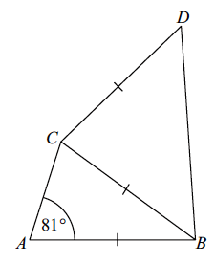

AB = BC = CD
Angle CAB = 81°

Angle CBD = 3 × angle ABC

Find
the size of angle ABC : the size of angle BCD

Give your answer in the form 1 : n
You must show all your working.

......................................................
(Total for Question 20 is 5 marks)
___________________________________________________________________________

21 (a) Factorise 6x – 15

......................................................
(1)
(b) Factorise m² + 5m

......................................................
(1)
(Total for Question 21 is 2 marks)
___________________________________________________________________________

21 (a) Factorise 8x – 18

......................................................
(1)
(b) Factorise n² + 7n

......................................................
(1)
(Total for Question 21 is 2 marks)
___________________________________________________________________________

22 Find the highest common factor (HCF) of 63 and 105

......................................................
(Total for Question 22 is 2 marks)
___________________________________________________________________________

22 Find the highest common factor (HCF) of 69 and 115

......................................................
(Total for Question 22 is 2 marks)
___________________________________________________________________________
23 (a) (i) Write 5.3 × 10⁴ as an ordinary number.

......................................................
(1)
(ii) Write 7.4 × 10^{–5} as an ordinary number.

......................................................
(1)
(b) Calculate the value of (9.7 × 10⁶) + (2.45 × 10⁷)
Give your answer in standard form.

......................................................
(2)
(Total for Question 23 is 4 marks)
___________________________________________________________________________

23 (a) (i) Write 6.2 × 10⁵ as an ordinary number.

......................................................
(1)

(ii) Write 2.4 × 10^{–6} as an ordinary number.

......................................................
(1)

(b) Calculate the value of 8.7 × 10⁵ + 3.56 × 10⁶
Give your answer in standard form.

......................................................
(2)
(Total for Question 23 is 4 marks)
___________________________________________________________________________

24 The diagram shows a solid triangular prism.

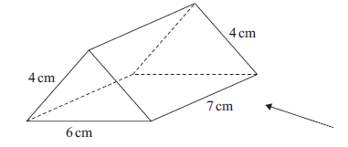

Rana is trying to draw the side elevation of the solid prism from the direction of
the arrow.

Here is her answer on a centimetre grid.

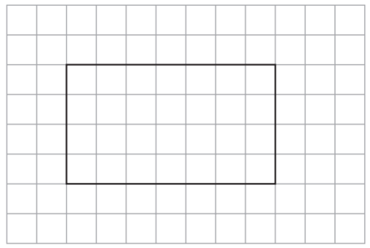

(a) Explain why Rana’s side elevation is not correct.

(1)

(b) On the centimetre grid below, draw a plan of the solid prism.

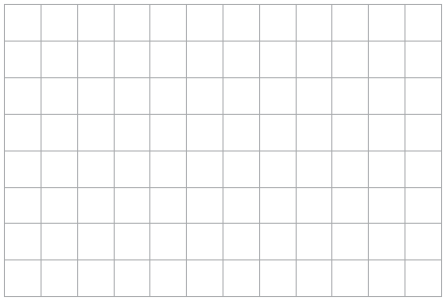
(2)
(Total for Question 24 is 3 marks)
___________________________________________________________________________

......................................................
(1)

(ii) Write 2.4 × 10^{–6} as an ordinary number.

......................................................
(1)

(b) Calculate the value of 8.7 × 10⁵ + 3.56 × 10⁶
Give your answer in standard form.

......................................................
(2)
(Total for Question 23 is 4 marks)
___________________________________________________________________________

24 The diagram shows a solid triangular prism.

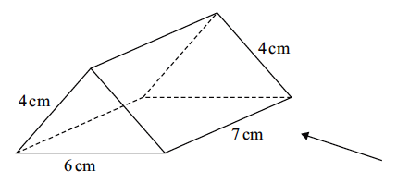

Rhona is trying to draw the plan of the solid prism.
Here is her answer on a centimetre grid.

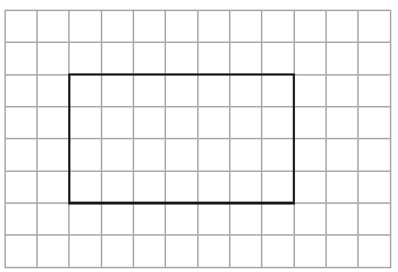

(a) Explain why Rhona’s plan is not correct.

...............................................................................................................................................

...............................................................................................................................................

...............................................................................................................................................
(1)
(b) On the centimetre grid below, draw a correct plan of the solid prism.

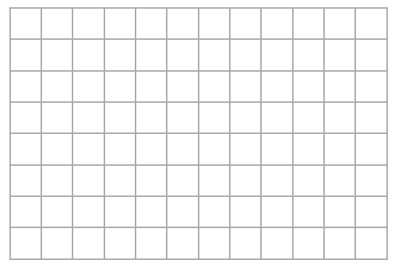
(2)
(Total for Question 24 is 3 marks)
___________________________________________________________________________

25 A company has 25 000 workers.
The number of workers increases at a rate of 6% per year for 3 years.
Calculate the total number of workers at the end of the 3 years.

......................................................
(Total for Question 25 is 4 marks)
___________________________________________________________________________
25 A library has 3 500 members.
The number of members increases at a rate of 7% per year for 3 years.

Calculate the total number of members at the end of the 3 years.

......................................................
(Total for Question 25 is 4 marks)
___________________________________________________________________________

26 Habib has two identical tins.
He puts 600 grams of flour into one of the tins.
The flour fills the tin completely.
The density of the flour is 0.6 g/cm³
Habib puts 600 grams of salt into the other tin.
The salt does not fill the tin completely.
The volume of the space in the tin that is not filled with salt is 700 cm³
Work out the density of the salt.
You must show all your working.

...................................................... g/cm³
(Total for Question 26 is 4 marks)
___________________________________________________________________________

26 Steven has two identical tins.

He puts 1800 grams of salt into one of the tins.
The salt fills the tin completely.
The density of the salt is 1.8 g/cm³

Steven puts 600 grams of flour into the other tin.
The flour does not fill the tin completely.
The volume of the space in the tin that is not filled with flour is 520 cm³

Work out the density of the flour.
You must show all your working.

...................................................... g/cm³
(Total for Question 26 is 4 marks)
___________________________________________________________________________

27 Tim has two biased coins, coin A and coin B.
He is going to throw both coins.
The probability that coin A will land on heads is 0.6
The probability that coin B will land on heads is 0.55
(a) Complete the probability tree diagram.

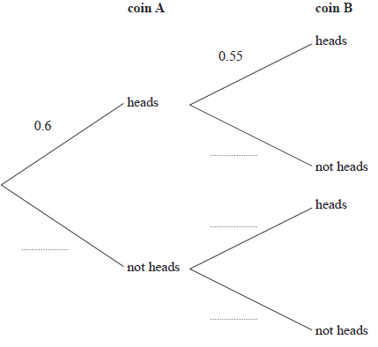
(2)

Tim throws coin A once and he throws coin B once.
(b) Work out the probability that both coins land on heads.

......................................................
(2)
(Total for Question 27 is 4 marks)
___________________________________________________________________________

27 Tom has two biased coins, coin A and coin B.
He is going to throw both coins. The coins will land on either heads or tails.

The probability that coin A will land on heads is 0.4
The probability that coin B will land on heads is 0.35

(a) Complete the probability tree diagram.

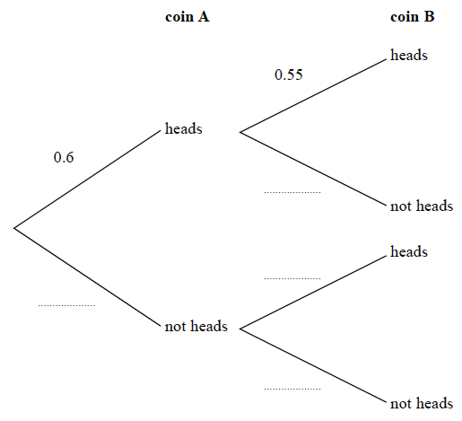
heads
heads
heads
tails
tails
tails
0.35
0.4
(2)

Tom throws coin A once and he throws coin B once.

(b) Work out the probability that both coins land on heads.

......................................................
(2)
(Total for Question 27 is 4 marks)
___________________________________________________________________________

28 A paddling pool is in the shape of a cylinder.
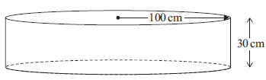
The pool has radius 100 cm.
The pool has depth 30 cm.

The pool is empty.
It is then filled with water at a rate of 250 cm³ per second.

Work out the number of minutes it takes to fill the pool completely.
Give your answer correct to the nearest minute.
You must show all your working.

...................................................... minutes
(Total for Question 28 is 4 marks)
___________________________________________________________________________

28 A paddling pool is in the shape of a cylinder.

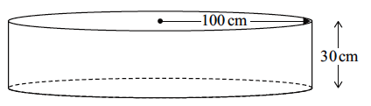
120 cm
40 cm

The pool has radius 120 cm.
The pool has depth 40 cm.

The pool is empty.
It is then filled with water at a rate of 320 cm³ per second.

Work out the number of minutes it takes to fill the pool completely.
Give your answer correct to the nearest minute.
You must show all your working.

...................................................... minutes
(Total for Question 28 is 4 marks)
___________________________________________________________________________

29 w = 40 – t²
(a) Calculate the value of w when t = –5

w = ......................................................

$$p=\frac{h-5}{3}$$

(b) Make $h$ the subject of the formula.

......................................................
(2)
(Total for Question 29 is 4 marks)
___________________________________________________________________________

29 k = 30 – 2t ²

(a) Calculate the value of k when t = –3

k = ......................................................
(2)

j = 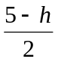

(b) Make h the subject of the formula.

......................................................
(2)
(Total for Question 29 is 4 marks)
___________________________________________________________________________

TOTAL FOR PAPER IS 80 MARKS

