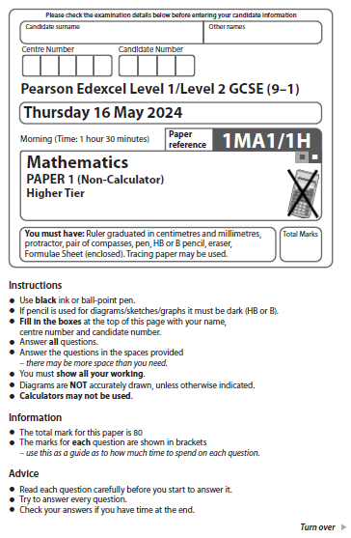
Answer ALL questions.
Write your answers in the spaces provided.
You must write down all the stages in your working.

1 Here are the first four terms of an arithmetic sequence.

1 | 5 | 9 | 13

Find an expression, in terms of n, for the nth term of this sequence.

.......................................................
(Total for Question 1 is 2 marks)
___________________________________________________________________________

1 Here are the first four terms of an arithmetic sequence.

7 12 17 22

Find an expression, in terms of n, for the nth term of this sequence.

.......................................................
(Total for Question 1 is 2 marks)
_________________________________________________________________________
2 (a) Work out $3\frac{4}{5}-1\frac{2}{3}$

.......................................................
(2)
Kevin was asked to work out $2\frac{1}{3}×\frac{5}{8}$
Here is his working and his answer.
$$2\frac{1}{3}×\frac{5}{8}=\frac{7}{3}×\frac{5}{8}$$
$=\frac{35}{24}$
$=1\frac{9}{24}$
Kevin’s answer is wrong.

(b) What mistake has Kevin made?

......................................................................................................................................................

......................................................................................................................................................

......................................................................................................................................................(1)
(Total for Question 21 is 3 marks)
___________________________________________________________________________

2 (a) Work out 4 – 2

.......................................................
(2)

Kora was asked to work out 2 ×

Here is her working and her answer.

2 × = 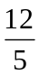×

= 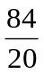

= 4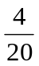

Kora’s answer is wrong.

(b) What mistake has Kora made?

......................................................................................................................................................

......................................................................................................................................................

......................................................................................................................................................
(1)
(Total for Question 2 is 3 marks)
___________________________________________________________________________

3 The diagram shows a plan of a floor.

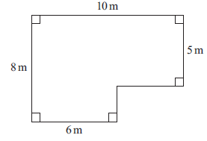

Petra is going to cover the floor with paint.
Petra has 3 tins of paint.
There are 2.5 litres of paint in each tin.
Petra thinks 1 litre of paint will cover 10 m² of floor.
(a) Assuming Petra is correct, does she have enough paint to cover the floor?
You must show all your working.

(4)
Actually, 1 litre of paint will cover 11 m² of floor.
(b) Does this affect your answer to part (a)?
You must give a reason for your answer.

......................................................................................................................................................

......................................................................................................................................................

......................................................................................................................................................(1)
(Total for Question 3 is 5 marks)
___________________________________________________________________________

3 The diagram shows a plan of a floor.

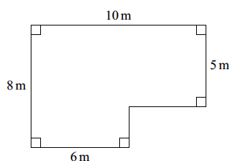

Peter is going to cover the floor with paint.

Peter has 4 tins of paint.
There are 1.5 litres of paint in each tin.

Peter thinks 1 litre of paint will cover 10 m² of floor.

(a) Assuming Peter is correct, does he have enough paint to cover the floor?
You must show all your working.

Actually, 1 litre of paint will cover 12 m² of floor.

(b) Does this affect your answer to part (a)?
You must give a reason for your answer.

...................................................................................................................................................

...................................................................................................................................................

...................................................................................................................................................
(1)
(Total for Question 3 is 5 marks)
___________________________________________________________________________

4 Here is a Venn diagram.

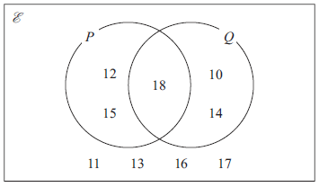

(a) Write down the numbers that are in set P′

.............................................................................................................
(1)
A number is chosen at random from the universal set, E
(b) Find the probability that this number is in the set P ∪ Q

.......................................................
(2)
(Total for Question 4 is 3 marks)
___________________________________________________________________________

4 Here is a Venn diagram.

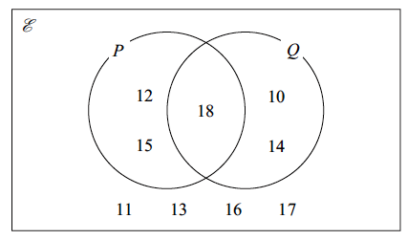

(a) Write down the numbers that are in set Q ′

.............................................................................................................
(1)

A number is chosen at random from the universal set,

(b) Find the probability that this number is in the set (P ∪ Q) ′

.......................................................
(2)
(Total for Question 4 is 3 marks)

5 Sophie drives a distance of 513 kilometres on a motorway in France.
She pays 0.81 euros for every 10 kilometres she drives.
(a) Work out an estimate for the total amount that Sophie pays.

....................................................... euros
(3)
(b) Is your answer to part (a) an underestimate or an overestimate?
Give a reason for your answer.

......................................................................................................................................................

......................................................................................................................................................

......................................................................................................................................................
(1)
(Total for Question 5 is 4 marks)
___________________________________________________________________________

5 Stan drives a distance of 2043 kilometres on motorways in Germany.
He pays 0.92 euros for every 100 kilometres he drives.

(a) Work out an estimate for the total amount that Stan pays.

....................................................... euros
(3)

(b) Is your answer to part (a) an underestimate or an overestimate?
Give a reason for your answer.

......................................................................................................................................................

......................................................................................................................................................

......................................................................................................................................................
(1)
(Total for Question 5 is 4 marks)
___________________________________________________________________________

6 Here is a straight line L drawn on a grid.

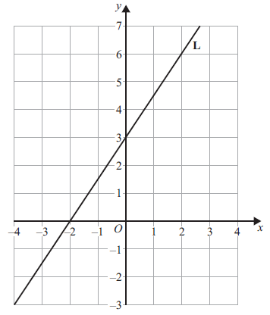

(a) Find an equation for L.

..................................................................................
(3)
M is a different straight line with equation y = 5x
(b) Write down the equation of a straight line parallel to M.

..................................................................................
(1)
(Total for Question 6 is 4 marks)
___________________________________________________________________________

6 Here is a straight line L drawn on a grid.

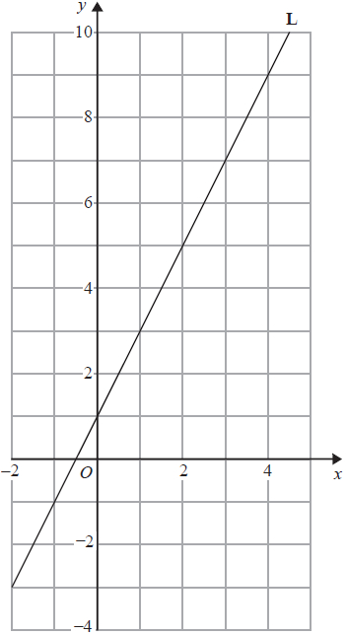

(a) Find an equation for L.

..................................................................................
(3)

M is a different straight line with equation y = 3x

(b) Write down the equation of a straight line parallel to M.

..................................................................................
(1)
(Total for Question 6 is 4 marks)
___________________________________________________________________________

7 Kasim has some small jars, some medium jars and some large jars.
He has a total of 400 jars.
$\frac{3}{8}$ of the 400 jars are empty.
For the empty jars,
number of small jars : number of medium jars = 3 : 4
number of medium jars : number of large jars = 1 : 2
Work out the percentage of Kasim’s jars that are empty small jars.

.......................................................%
(Total for Question 7 is 5 marks)
___________________________________________________________________________

7 Keisha has some small bottles, some medium bottles and some large bottles.
She has a total of 600 bottles.

of the 600 bottles are green.

For the green bottles,

number of small bottles : number of medium bottles = 4 : 3
number of medium bottles : number of large bottles = 3 : 5

Work out the percentage of Keisha’s bottles that are medium green bottles.

8 Len has 8 parcels
The mean weight of the 8 parcels is 2.5 kg.
The mean weight of 3 of the parcels is 2 kg.
Work out the mean weight of the other 5 parcels.

....................................................... kg
(Total for Question 8 is 3 marks)
___________________________________________________________________________

8 Lola has 16 crates.

The mean weight of the 16 crates is 50 kg.
The mean weight of 6 of the crates is 40 kg.

Work out the mean weight of the other 10 crates.

....................................................... kg
(Total for Question 8 is 3 marks)
___________________________________________________________________________

9 In a sale, the normal price of a coat is reduced by R%
Given that
sale price = 0.7 × normal price
find the value of R.

R = .......................................................
(Total for Question 9 is 1 mark)
___________________________________________________________________________

9 In a sale, the normal price of a laptop is reduced by R%

Given that
sale price = 0.9 × normal price

find the value of R.

R = .......................................................
(Total for Question 9 is 1 mark)
___________________________________________________________________________

10 Solve the simultaneous equations
5x – 2y = 23
2x – 3y = 18

x = ............................

y = ............................
(Total for Question 10 is 4 marks)
___________________________________________________________________________

10 Solve the simultaneous equations

2x – 6y = 22
3x – 4y = 23

x = ............................

y = ............................
(Total for Question 10 is 4 marks)
___________________________________________________________________________

11
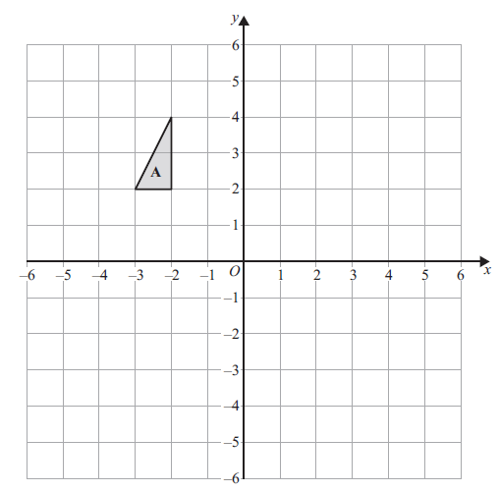
Triangle A is translated by the vector $\left({6 \atop -4}\right)$ to give triangle B.
Triangle B is rotated 90 clockwise about the point (1, 2) to give triangle C.
Describe fully the single transformation that maps triangle A onto triangle C.

......................................................................................................................................................

......................................................................................................................................................

......................................................................................................................................................
(Total for Question 11 is 3 marks)
___________________________________________________________________________

11
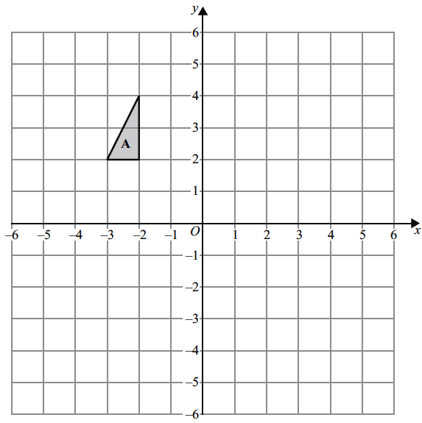

Triangle A is translated by the vector 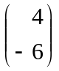 to give triangle B.
Triangle B is rotated 90° clockwise about the point (0, –2) to give triangle C.

Describe fully the single transformation that maps triangle A onto triangle C.

......................................................................................................................................................

......................................................................................................................................................

......................................................................................................................................................
(Total for Question 11 is 3 marks)
___________________________________________________________________________

12 Here are some graphs.

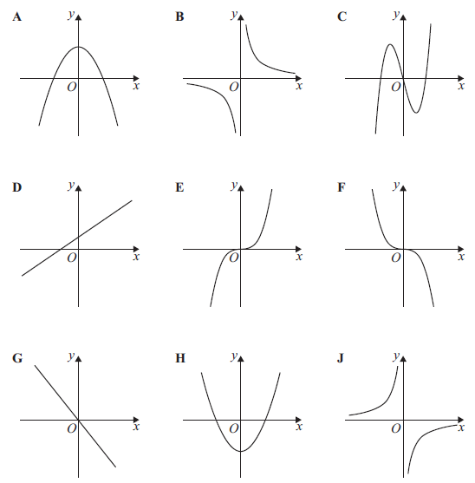

Write down the letter of the graph that could have the equation
(i) y = x² – 4
............................
(1)
(ii) y = –x³
............................
(1)
(iii) y = $-\frac{5}{x}$
............................
(1)
(Total for Question 12 is 3 marks)

___________________________________________________________________________

12 Here are some graphs.
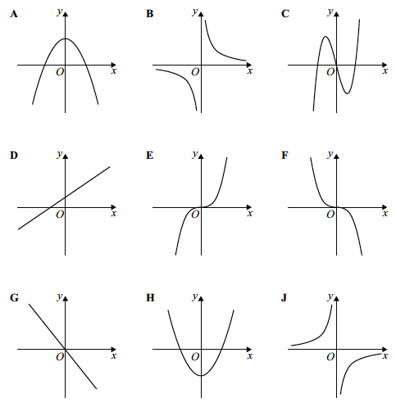

Write down the letter of the graph that could have the equation

(i) y = –x
............................
(1)

(ii) y = x³
............................
(1)

(iii) y = x³ – 2x
............................
(1)
(Total for Question 12 is 3 marks)
___________________________________________________________________________
13 The table gives information about the amount of time that each of 150 people
were in a shop.

Time (t minutes) | Frequency
0 < t ≤ 10 | 20
10 < t ≤ 30 | 70
30 < t ≤ 35 | 22
35 < t ≤ 50 | 30
50 < t ≤ 60 | 8

(a) On the grid, draw a histogram for this information.
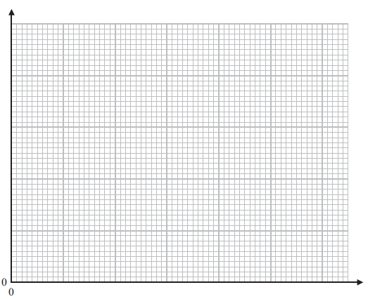(3)
(b) Work out an estimate for the fraction of these 150 people who were in the shop for
between 20 minutes and 40 minutes.

.......................................................
(2)
(Total for Question 13 is 5 marks)
___________________________________________________________________________
13 The table gives information about the amount of time that each of 150 people were in an art gallery.

Time (t minutes) | Frequency
0 < t ≤ 10 | 10
10 < t ≤ 30 | 80
30 < t ≤ 35 | 23
35 < t ≤ 50 | 30
50 < t ≤ 60 | 7

(a) On the grid, draw a histogram for this information.
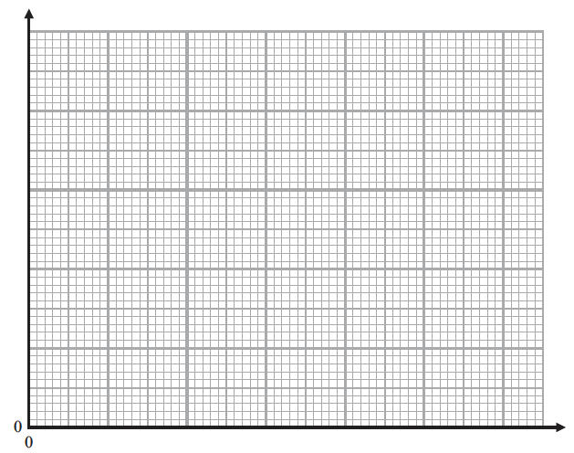
(3)

(b) Work out an estimate for the fraction of these 150 people who were in the art gallery for
between 15 minutes and 45 minutes.

.......................................................
(2)
(Total for Question 13 is 5 marks)
___________________________________________________________________________

14 Expand and simplify (3x – 1)(2x + 3)(x – 5)

.................................................................................
(Total for Question 14 is 3 marks)
___________________________________________________________________________

14 Expand and simplify (4x – 2)(3x + 1)(x – 7)

.................................................................................
(Total for Question 14 is 3 marks)
_________________________________________________________________________
15 OAB is a sector of a circle with centre O and radius 6 cm.
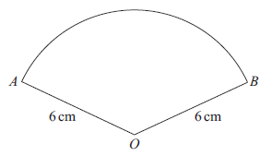
The length of the arc AB is 5π cm.
Work out, in terms of π, the area of the sector.
Give your answer in its simplest form.

....................................................... cm²
(Total for Question 15 is 4 marks)
___________________________________________________________________________

15 OAB is a sector of a circle with centre O and radius 8 cm.
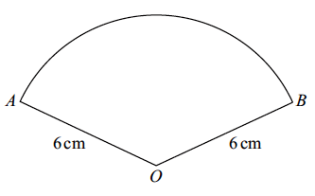
8 cm
8 cm

The length of the arc AB is 6π cm.

Work out, in terms of π, the area of the sector.
Give your answer in its simplest form.

....................................................... cm²
(Total for Question 15 is 4 marks)
___________________________________________________________________________

16 There are only $n$ orange sweets and 1 white sweet in a bag.
Saira takes at random a sweet from the bag and eats the sweet.
She then takes at random another sweet from the bag and eats this sweet.
Show that the probability that Saira eats two orange sweets is $\frac{n-1}{n+1}$

(Total for Question 16 is 2 marks)
___________________________________________________________________________

16 There are only n yellow sweets and 1 orange sweet in a bag.

Sandra takes at random a sweet from the bag and eats the sweet.
She then takes at random another sweet from the bag and eats this sweet.
Show that the probability that Sandra eats one yellow sweet and one orange sweet is 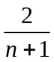

(Total for Question 16 is 2 marks)
___________________________________________________________________________

17 (a) Rationalise the denominator of $\frac{1}{\sqrt{7}}$

.......................................................
(1)
(b) Simplify fully $\sqrt{80}-\sqrt{5}$

.......................................................
(2)
(Total for Question 17 is 3 marks)
___________________________________________________________________________
17 (a) Rationalise the denominator of 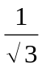

.......................................................
(1)

(b) Simplify fully √32 – √8

.......................................................
(2)
(Total for Question 17 is 3 marks)
___________________________________________________________________________

18 Show that $0.\dot{1}\dot{5}+0.2\dot{2}\dot{7}$ can be written in the form $\frac{m}{66}$ where $m$ is an integer.

(Total for Question 18 is 3 marks)
___________________________________________________________________________

18 Show that 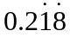 + 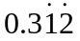 can be written in the form 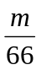 where m is an integer.

(Total for Question 18 is 3 marks)
___________________________________________________________________________

19
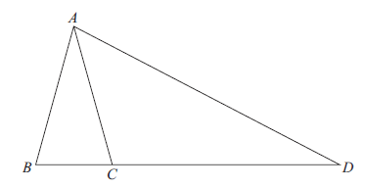
ABC and DAB are similar isosceles triangles.
AB = AC
AD = BD
BC : CD = 4 : 21
Find the ratio AB : AD

.......................................................
(Total for Question 19 is 3 marks)
___________________________________________________________________________

19
A
C
B
D

ABC and DAB are similar isosceles triangles.

AB = AC
AD = BD

BC : CD = 9 : 7

Find the ratio AB : AD

.......................................................
(Total for Question 19 is 3 marks)
___________________________________________________________________________
20 $2^{x}=\frac{2^{n}}{\sqrt[3]{2}}$ $2^{y}={\left(\sqrt{2}\right)}^{5}$

Given that x + y = 8
work out the value of n.

n = .......................................................
(Total for Question 20 is 3 marks)
___________________________________________________________________________

20 2^{x} = 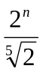 2^{y} = (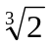)⁷

Given that x + y = 6

work out the value of n.

n = .......................................................
(Total for Question 20 is 3 marks)
___________________________________________________________________________

21 A solid cuboid has a volume of 300 cm³
The cuboid has a total surface area of 370 cm²
The length of the cuboid is 20 cm.
The width of the cuboid is greater than the height of the cuboid.
Work out the height of the cuboid.
You must show all your working.

....................................................... cm
(Total for Question 21 is 5 marks)
___________________________________________________________________________

21 A solid cuboid has a volume of 84 cm³
The cuboid has a total surface area of 118 cm²

The length of the cuboid is 6 cm.
The width of the cuboid is greater than the height of the cuboid.

Work out the height of the cuboid.
You must show all your working.

....................................................... cm
(Total for Question 21 is 5 marks)
___________________________________________________________________________

22 (a) Sketch the graph of y = sin x° for 0 ≤ x ≤ 360

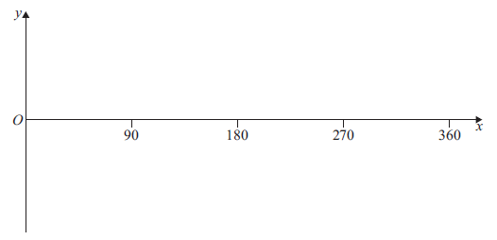
(2)
(b) Solve the equation 2 sin x° = –1 for 0 ≤ x ≤ 360

.................................................................................
(2)
(Total for Question 22 is 4 marks)
___________________________________________________________________________

22 (a) Sketch the graph of y = cos x° for 0 ≤ x ≤ 360

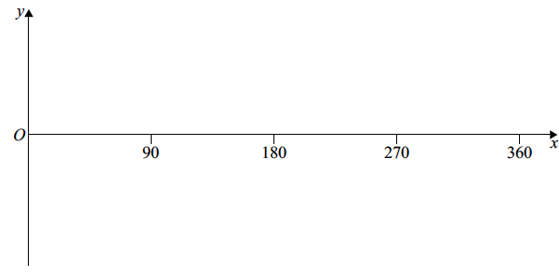
(2)

(b) Solve the equation 2 cos x° = –1 for 0 ≤ x ≤ 360

.................................................................................
(2)
(Total for Question 22 is 4 marks)
___________________________________________________________________________

23 C is a circle with centre (0, 0)
L is a straight line.
The circle C and the line L intersect at the points P and Q.
The coordinates of P are (5, 10)
The x coordinate of Q is –2
L has a positive gradient and crosses the y-axis at the point (0, k)
Find the value of k.

k = .......................................................
(Total for Question 23 is 5 marks)

23 C is a circle with centre (0, 0)
L is a straight line.

The circle C and the line L intersect at the points P and Q.
The coordinates of P are (6, 7)
The x coordinate of Q is –2

L has a positive gradient and crosses the y-axis at the point (0, k)

Find the value of k.

k = .......................................................
(Total for Question 23 is 5 marks)

___________________________________________________________________________
TOTAL FOR PAPER IS 80 MARKS

