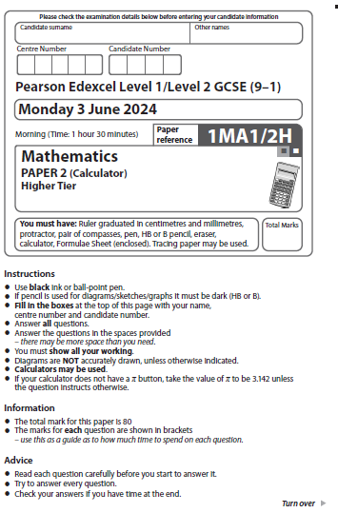
Answer ALL questions.
Write your answers in the spaces provided.
You must write down all the stages in your working.

1 ABC is a right-angled triangle.
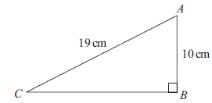

Work out the length of CB.
Give your answer correct to 3 significant figures.

...................................................... cm
(Total for Question 1 is 2 marks)
___________________________________________________________________________

1 ABC is a right-angled triangle.
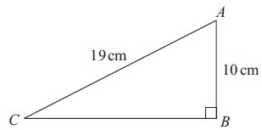

15 cm
18 cm

Work out the length of AB.
Give your answer correct to 3 significant figures.

...................................................... cm
(Total for Question 1 is 2 marks)

2 (a) Write 90 as a product of its prime factors.

......................................................
(2)
A = 2² × 3
B = 2 × 3²
(b) Write down the lowest common multiple (LCM) of A and B.

......................................................
(1)
(Total for Question 2 is 3 marks)
___________________________________________________________________________

2 (a) Write 60 as a product of its prime factors.

......................................................
(2)

A = 2³ × 3²
B = 2 × 3³

(b) Write down the lowest common multiple (LCM) of A and B.

......................................................
(1)
(Total for Question 2 is 3 marks)

3 The number of hours, H, that some machines take to make 5000 bottles is given by

H = $\frac{72}{n}$ where $n$ is the number of machines.
On Monday, 6 machines made 5000 bottles.
On Tuesday, 9 machines made 5000 bottles.
The machines took more time to make the bottles on Monday than on Tuesday.
How much more time?

........................... hours
(Total for Question 3 is 2 marks)
___________________________________________________________________________

3 The number of hours, H, that some machines take to make 8000 widgets is given by

H = 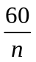 where n is the number of machines.

On Monday, 15 machines made 8000 widgets.
On Tuesday, 10 machines made 8000 widget.

The machines took more time to make the widgets on Tuesday than on Monday.

How much more time?

........................... hours
(Total for Question 3 is 2 marks)
___________________________________________________________________________

4 There are only red discs, blue discs and yellow discs in a bag.
There are 24 yellow discs in the bag.
Mel is going to take at random a disc from the bag.
The probability that the disc will be yellow is 0.16
the number of red discs : the number of blue discs = 5 : 4
Work out the number of red discs in the bag.

......................................................
(Total for Question 4 is 4 marks)
___________________________________________________________________________

4 There are only red sweets, orange sweets and yellow sweets in a jar.
There are 36 orange sweets in the jar.

Hannah is going to take at random a sweet from the jar.

The probability that the sweet will be orange is 0.18

the number of red sweets : the number of yellow sweets = 1 : 3

Work out the number of yellow sweets in the jar.

......................................................
(Total for Question 4 is 4 marks)
___________________________________________________________________________

5 (a) Complete the table of values for y = x² – x

x | –2 | –1 | 0 | 1 | 2 | 3
y | 6 |  | 0 |  | 2
(2)
(b) On the grid, draw the graph of y = x² – x for values of x from –2 to 3
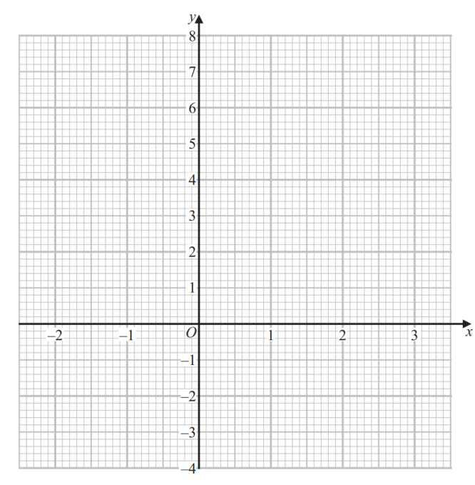
(2)
(c) Use your graph to find estimates for the solutions of the equation x² – x = 4

............................................................................................................
(2)
(Total for Question 5 is 6 marks)
___________________________________________________________________________

5 (a) Complete the table of values for y = x² – 2x

x | –2 | –1 | 0 | 1 | 2 | 3
y | 8 |  | 0 |  | 0

(2)

(b) On the grid, draw the graph of y = x² – 2x for values of x from –2 to 3
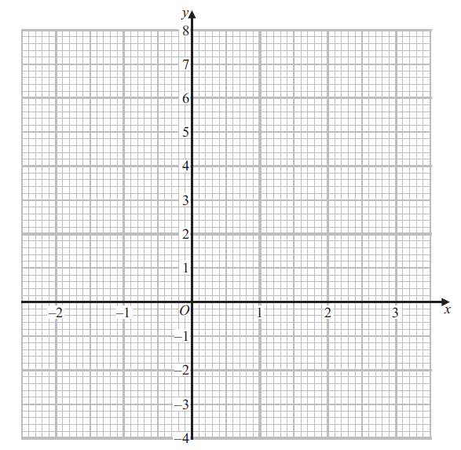 (2)

(c) Use your graph to find estimates for the solutions of the equation x² – 2x = 2

...............................................................
(2)
(Total for Question 5 is 6 marks)
___________________________________________________________________________

6 Andy, Luke and Tina share some sweets in the ratio 1 : 6 : 14
Tina gives $\frac{3}{7}$ of her sweets to Andy.
Tina then gives $12\frac{1}{2}$ % of the rest of her sweets to Luke.
Tina says,
“Now all three of us have the same number of sweets.”
Is Tina correct?
You must show how you get your answer.

(Total for Question 6 is 4 marks)
___________________________________________________________________________

6 Aaron, Lucy and Tom share some money in the ratio 4 : 9 : 14
Tom gives of his money to Aaron.
Tom then gives 10% of the rest of his money to Lucy.

Tom says,

“Now all three of us have the same amount of money.”

Is Tom correct?
You must show how you get your answer.

(Total for Question 6 is 4 marks)
___________________________________________________________________________

7 ABCD is a quadrilateral.

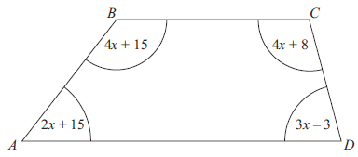
All angles are measured in degrees.
Show that ABCD is a trapezium.

(Total for Question 7 is 4 marks)
___________________________________________________________________________

7 ABCD is a quadrilateral.

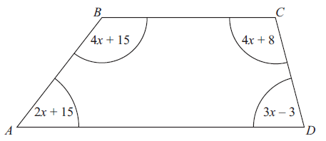
4x + 30
3x – 11
5x + 4
3x – 8
A
B
C
D

All angles are measured in degrees.

Show that ABCD is a trapezium.

(Total for Question 7 is 4 marks)
___________________________________________________________________________
8 A playground is in the shape of a right-angled triangle.
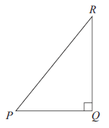

Dan makes a scale drawing of the playground.
He uses a scale of 1 cm represents 5 m
The area of the playground on the scale drawing is 28 cm²
The real length of QR is 40 m
Work out the real length of PQ.

...................................................... m
(Total for Question 8 is 3 marks)
___________________________________________________________________________

8 A carpet is in the shape of a right-angled triangle.

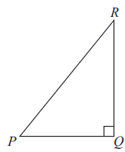

Denise makes a scale drawing of the carpet.
She uses a scale of 1 cm represents 50 cm

The area of the carpet on the scale drawing is 60 cm²

The real length of QR is 6 m

Work out the real length of PQ.

...................................................... m
(Total for Question 8 is 3 marks)
___________________________________________________________________________

9 A number N is rounded to 2 significant figures.
The result is 7.3
(a) Write down the least possible value of N.
......................................................
(1)
Leila says,
“The value of N cannot be greater than 7.349 because 7.350 would round up to 7.4”
(b) Is Leila correct?
You must give a reason for your answer.

......................................................................................................................................................

......................................................................................................................................................

......................................................................................................................................................
(1)
(Total for Question 9 is 2 marks)
___________________________________________________________________________

9 A number N is rounded to 2 significant figures.
The result is 8.6

(a) Write down the least possible value of N.

......................................................
(1)

Linda says,

“The value of N cannot be 8.649 because 8.649 would round up to 8.65
and 8.65 would round up 8.7”

(b) Is Linda correct?
You must give a reason for your answer.

...............................................................................................................................................

...............................................................................................................................................

...............................................................................................................................................
(1)
(Total for Question 9 is 2 marks)
________________________________________________________________________

10 The diagram shows two right-angled triangles.

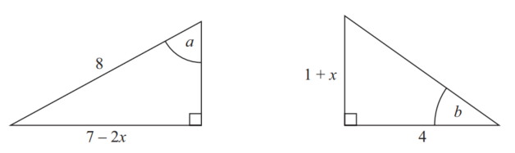
All lengths are measured in centimetres.
Given that
sin a = tan b
work out the value of x.

x = ......................................................
(Total for Question 10 is 3 marks)
___________________________________________________________________________

10 The diagram shows two right-angled triangles.

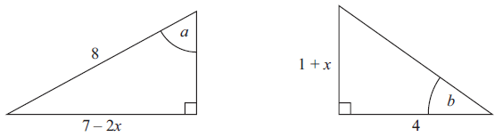
x + 2
6
12

5 – 2x

All lengths are measured in centimetres.

Given that

cos a = tan b

work out the value of x.

x = ......................................................
(Total for Question 10 is 3 marks)
___________________________________________________________________________

11 The frequency table gives information about the weights of 60 parcels.
Weight (w kg) | Frequency
0 < w ≤ 2 | 7
2 < w ≤ 4 | 21
4 < w ≤ 6 | 15
6 < w ≤ 8 | 11
8 < w ≤ 10 | 6

(a) Complete the cumulative frequency table.

Weight (w kg) | Cumulative frequency
0 < w ≤ 2
0 < w ≤ 4
0 < w ≤ 6
0 < w ≤ 8
0 < w ≤ 10
(1)
(b) On the grid on the next page, draw a cumulative frequency graph for your table.
(2)

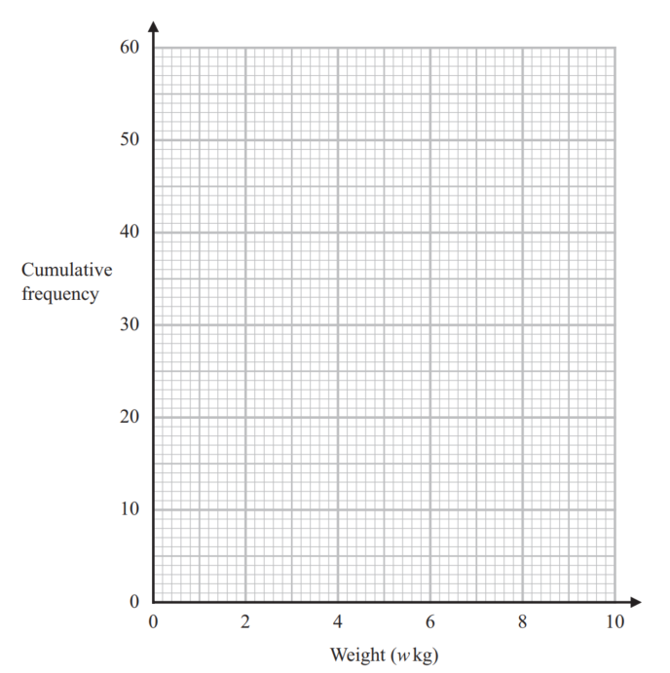

(c) Use your graph to find an estimate for the interquartile range.

...................................................... kg
(2)
(d) Use your graph to find an estimate for the number of these parcels with a weight
greater than 7.4 kg.

......................................................
(2)
(Total for Question 11 is 7 marks)
___________________________________________________________________________

11 The frequency table gives information about the weights of 60 packages.

Weight (w kg) | Frequency
0 < w ≤ 2 | 9
2 < w ≤ 4 | 20
4 < w ≤ 6 | 15
6 < w ≤ 8 | 10
8 < w ≤ 10 | 6

(a) Complete the cumulative frequency table.

Weight (w kg) | Cumulative  frequency
0 < w ≤ 2
0 < w ≤ 4
0 < w ≤ 6
0 < w ≤ 8
0 < w ≤ 10
(1)

(b) On the grid opposite, draw a cumulative frequency graph for your table.
(2)
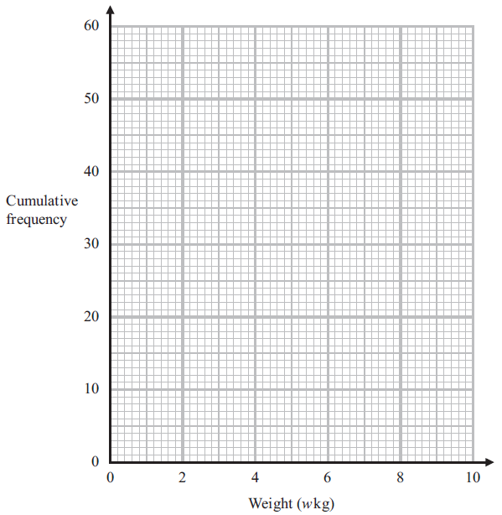

(c) Use your graph to find an estimate for the interquartile range.

...................................................... kg
(2)

(d) Use your graph to find an estimate for the number of these packages with a weight greater than 5.6 kg.

......................................................
(2)
(Total for Question 11 is 7 marks)
___________________________________________________________________________

12 f is inversely proportional to d ²
f = 3.5 when d = 8
(a) Find an equation for f in terms of d.

......................................................
(2)
(b) Find the positive value of d when f = 10
Give your answer correct to 3 significant figures.

d = ......................................................
(2)
(Total for Question 12 is 4 marks)
___________________________________________________________________________

12 g is inversely proportional to h ²

g = 2.5 when h = 10

(a) Find an equation for g in terms of h.

......................................................
(2)

(b) Find the positive value of h when g = 8
Give your answer correct to 2 significant figures.

d = ......................................................
(2)
(Total for Question 12 is 4 marks)

13
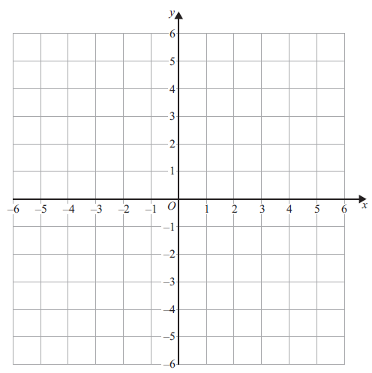

On the grid, shade the region R that satisfies all the following inequalities.
x ≤ 2 | y ≥ –3 | y ≤ 2x + 1 | 3x + 2y ≤ 6
Label the region R.

(Total for Question 13 is 3 marks)
___________________________________________________________________________

13
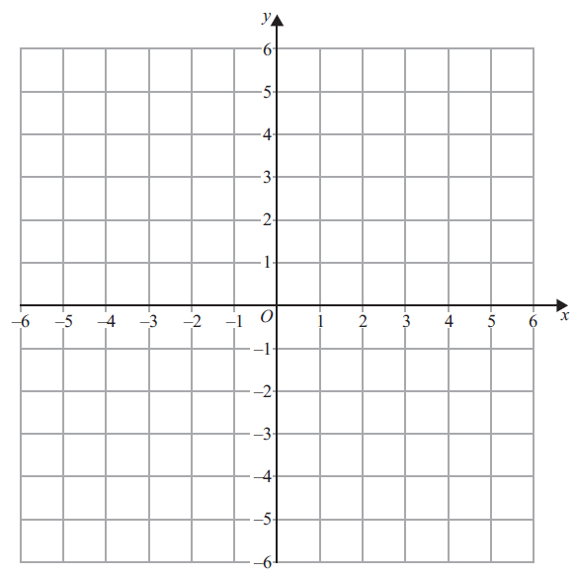

On the grid, shade the region R that satisfies all the following inequalities.

x ≤ 3 y ≥ –2 y ≤ 2x + 2 2x + 3y ≤ 6

Label the region R.

(Total for Question 13 is 3 marks)
___________________________________________________________________________

14 The graph shows the velocity of a car, in metres per second, t seconds after it starts to
slow down.

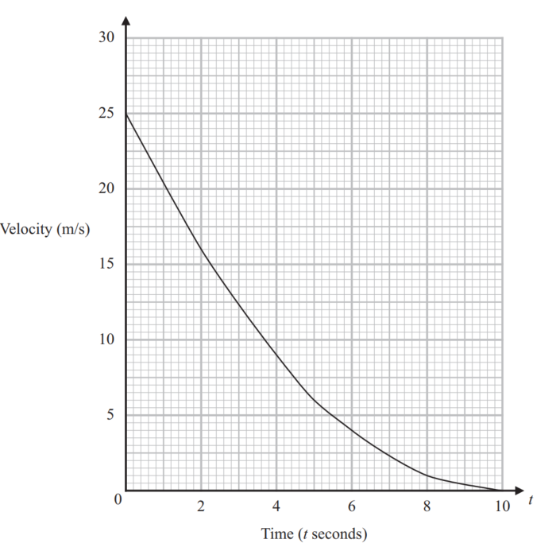
(a) Calculate an estimate for the acceleration of the car when t = 5
You must show all your working.

...................................................... m/s²
(3)

(b) Work out an estimate for the distance the car travels in the first 6 seconds after it
starts to slow down.
Use 3 strips of equal width.

...................................................... m
(3)
(Total for Question 14 is 6 marks)
___________________________________________________________________________

14 The graph shows the velocity of a van, in metres per second, t seconds after it starts to
slow down.

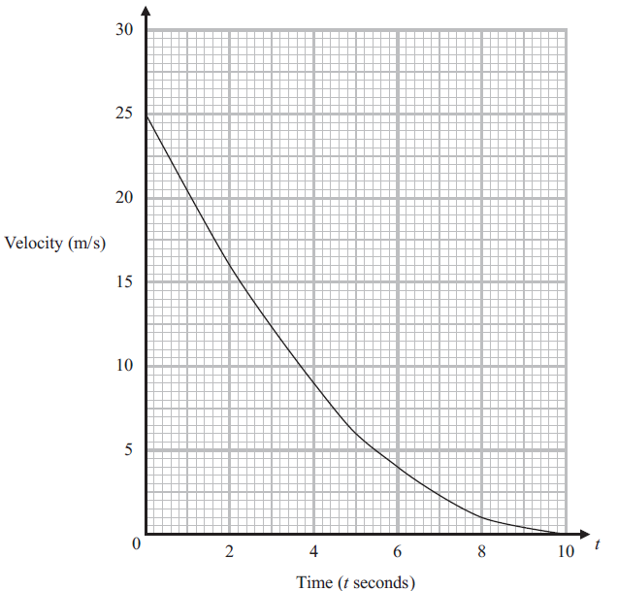

(a) Calculate an estimate for the acceleration of the van when t = 6
You must show all your working.

...................................................... m/s²
(3)

(b) Work out an estimate for the distance the van travels in the first 4 seconds after it starts to slow down.
Use 4 strips of equal width.

...................................................... m
(3)
(Total for Question 14 is 6 marks)
___________________________________________________________________________

15 Given that $a$ is a prime number, rationalise the denominator of $\frac{1}{\sqrt{a}+1}$
Give your answer in its simplest form.

......................................................
(Total for Question 15 is 2 marks)
___________________________________________________________________________

15 Given that b is a prime number, rationalise the denominator of 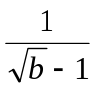
Give your answer in its simplest form.

......................................................
(Total for Question 15 is 2 marks)
___________________________________________________________________________

16 Solve (4x – 3) (x + 5) < 0

.................................................................................
(Total for Question 16 is 2 marks)
___________________________________________________________________________

16 Solve (5x – 3) (x + 6) < 0

.................................................................................
(Total for Question 16 is 2 marks)
___________________________________________________________________________

17 L, M and P are three similar solid cylinders made from the same material.
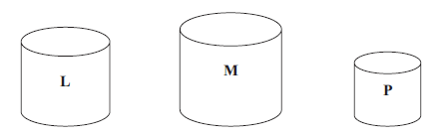
L has a mass of 64 g
M has a mass of 125 g
M has a total surface area of 144 cm²
P has a total surface area of 16 cm²
Work out
height of cylinder L : height of cylinder M : height of cylinder P

.................................................................................
(Total for Question 17 is 4 marks)
___________________________________________________________________________

17 A, B and C are three similar solid cylinders made from the same material.

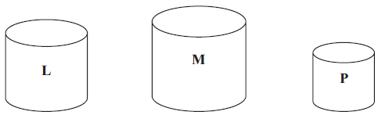
A
B
C

A has a mass of 125 g
B has a mass of 216 g

B has a total surface area of 100 cm²
C has a total surface area of 25 cm²

Work out
height of cylinder A : height of cylinder B : height of cylinder C

.................................................................................
(Total for Question 17 is 4 marks)
___________________________________________________________________________
18 There are only 4 red counters, 3 yellow counters and 1 green counter in a bag.
Tony takes at random three counters from the bag.
Work out the probability that there are now more yellow counters than red counters in
the bag.
You must show all your working.

......................................................
(Total for Question 18 is 5 marks)
___________________________________________________________________________

18 There are only 3 red counters, 3 yellow counters and 2 green counters in a bag.

Tina takes at random three counters from the bag.

Work out the probability that there are now more red counters than yellow counters in
the bag.
You must show all your working.

......................................................
(Total for Question 18 is 5 marks)
___________________________________________________________________________

19 The diagram shows quadrilateral $OACB$.

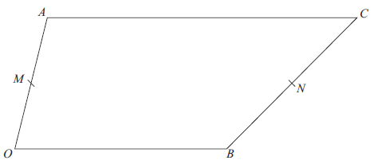

$M$ is the midpoint of $OA$.
$N$ is the point on $BC$ such that $BN$ : $NC$ = 4 : 5
$\vec{OA}$ = a $\vec{OB}$ = b $\vec{AC}$= kb where k is a positive integer.
(a) Express $\vec{MN}$ in terms of k, a and b.
Give your answer in its simplest form.

......................................................
(4)
(b) Is $MN$ parallel to $OB$?
Give a reason for your answer.
......................................................................................................................................................

......................................................................................................................................................

......................................................................................................................................................
(Total for Question 19 is 5 marks)
___________________________________________________________________________
19 The diagram shows quadrilateral OACB.

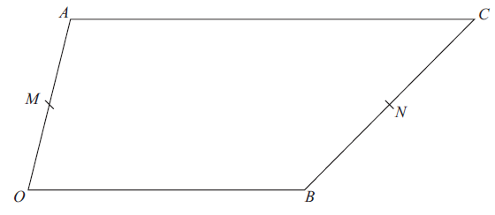

M is the midpoint of OA.
N is the point on BC such that BN : NC = 5 : 6

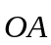 = a 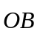 = b 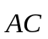 = kb where k is a positive integer.

(a) Express 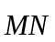 in terms of k, a and b.
Give your answer in its simplest form.

......................................................
(4)

(b) Is MN parallel to OB?
Give a reason for your answer.

...............................................................................................................................................

...............................................................................................................................................

...............................................................................................................................................
(1)
(Total for Question 19 is 5 marks)
___________________________________________________________________________
20 The curve C has equation y = 2x² – 12x + 7
Find the coordinates of the turning point on C.

(............................ , ............................)
(Total for Question 20 is 3 marks)
___________________________________________________________________________

20 The curve C has equation y = 2x² – 20x + 30

Find the coordinates of the turning point on C.

(............................ , ............................)
(Total for Question 20 is 3 marks)
___________________________________________________________________________

21 The graph of y = g(x) is shown on the grid.

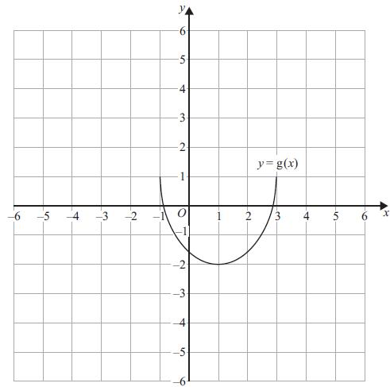

On the grid, draw the graph of y = g(– x) + 2

(Total for Question 21 is 2 marks)
___________________________________________________________________________

21 The graph of y = g(x) is shown on the grid.

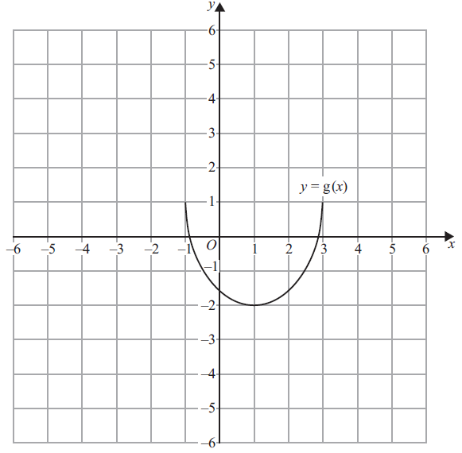

On the grid, draw the graph of y = g(–x) – 2

(Total for Question 21 is 2 marks)
___________________________________________________________________________

22 A and B are points on a circle, centre O.

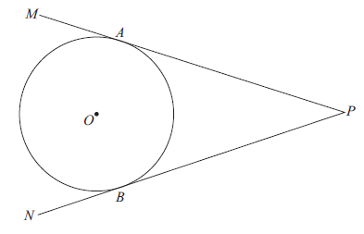
MAP and NBP are tangents to the circle.
Prove that AP = BP

(Total for Question 22 is 4 marks)

22 A, B, C and D are four points on a circle.
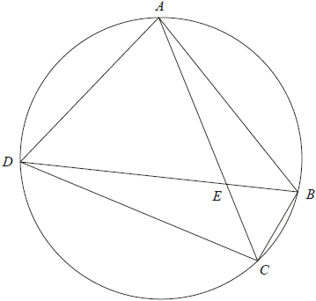
AEC and DEB are straight lines.
Triangle AED is an equilateral triangle.

Prove that triangle ABC is congruent to triangle DCB.

(Total for Question 22 is 4 marks)
___________________________________________________________________________

TOTAL FOR PAPER IS 80 MARKS

