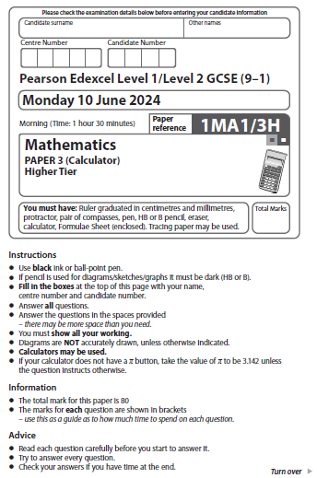
Answer ALL questions.
Write your answers in the spaces provided.
You must write down all the stages in your working.

1 Find the highest common factor (HCF) of 63 and 105

......................................................
(Total for Question 1 is 2 marks)
___________________________________________________________________________

1 Find the highest common factor (HCF) of 69 and 115

......................................................
(Total for Question 1 is 2 marks)

2 (a) (i) Write 5.3 × 10⁴ as an ordinary number.

......................................................
(1)
(ii) Write 7.4 × 10^{–5} as an ordinary number.

......................................................
(1)
(b) Calculate the value of 9.7 × 10⁶ + 2.45 × 10⁷
Give your answer in standard form.

......................................................
(2)
(Total for Question 2 is 4 marks)
___________________________________________________________________________
2 (a) (i) Write 6.2 × 10⁵ as an ordinary number.

......................................................
(1)

(ii) Write 2.4 × 10^{–6} as an ordinary number.

......................................................
(1)

(b) Calculate the value of 8.7 × 10⁵ + 3.56 × 10⁶
Give your answer in standard form.

......................................................
(2)
(Total for Question 2 is 4 marks)
3 The diagram shows a solid triangular prism.

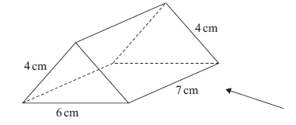

Rana is trying to draw the side elevation of the solid prism from the direction of
the arrow.

Here is her answer on a centimetre grid.

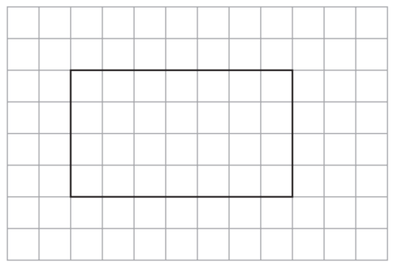

(a) Explain why Rana’s side elevation is not correct.

......................................................................................................................................................

......................................................................................................................................................

......................................................................................................................................................
(1)

(b) On the centimetre grid below, draw a plan of the solid prism.

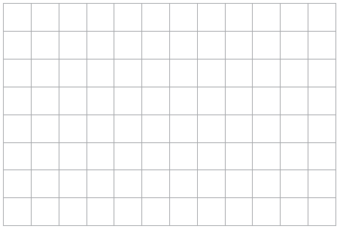
(2)
(Total for Question 3 is 3 marks)
___________________________________________________________________________

3 The diagram shows a solid triangular prism.

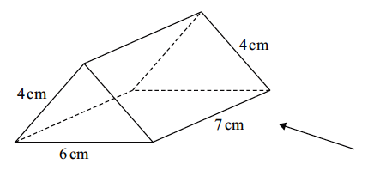

Rhona is trying to draw the plan of the solid prism.
Here is her answer on a centimetre grid.

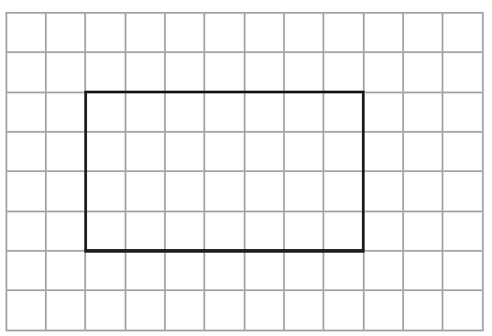

(a) Explain why Rhona’s plan is not correct.

...............................................................................................................................................

...............................................................................................................................................

...............................................................................................................................................
(1)
(b) On the centimetre grid below, draw a correct plan of the solid prism.

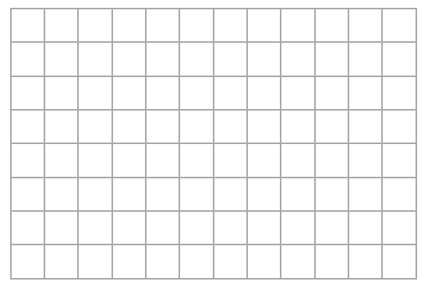
(2)
(Total for Question 3 is 3 marks)

4 A company has 25 000 workers.
The number of workers increases at a rate of 6% per year for 3 years.
Calculate the total number of workers at the end of the 3 years.

......................................................
(Total for Question 4 is 4 marks)
___________________________________________________________________________

4 A library has 3 500 members.
The number of members increases at a rate of 7% per year for 3 years.

Calculate the total number of members at the end of the 3 years.

......................................................
(Total for Question 4 is 4 marks)
___________________________________________________________________________

5 Habib has two identical tins.
He puts 600 grams of flour into one of the tins.
The flour fills the tin completely.
The density of the flour is 0.6 g/cm³
Habib puts 600 grams of salt into the other tin.
The salt does not fill the tin completely.
The volume of the space in the tin that is not filled with salt is 700 cm³
Work out the density of the salt.
You must show all your working.

...................................................... g/cm³
(Total for Question 5 is 4 marks)
___________________________________________________________________________

5 Steven has two identical tins.

He puts 1800 grams of salt into one of the tins.
The salt fills the tin completely.
The density of the salt is 1.8 g/cm³

Steven puts 600 grams of flour into the other tin.
The flour does not fill the tin completely.
The volume of the space in the tin that is not filled with flour is 520 cm³

Work out the density of the flour.
You must show all your working.

...................................................... g/cm³
(Total for Question 5 is 4 marks)
___________________________________________________________________________

6 Tim has two biased coins, coin A and coin B.
He is going to throw both coins.
The probability that coin A will land on heads is 0.6
The probability that coin B will land on heads is 0.55
(a) Complete the probability tree diagram.

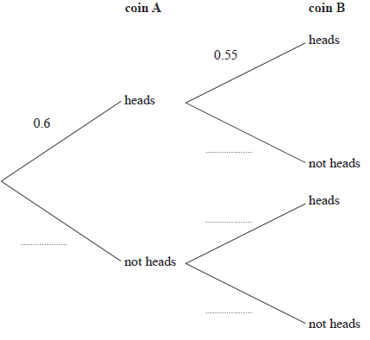
(2)
Tim throws coin A once and he throws coin B once.
(b) Work out the probability that both coins land on heads.

......................................................
(2)
(Total for Question 6 is 4 marks)
___________________________________________________________________________

6 Tom has two biased coins, coin A and coin B.
He is going to throw both coins. The coins will land on either heads or tails.

The probability that coin A will land on heads is 0.4
The probability that coin B will land on heads is 0.35

(a) Complete the probability tree diagram.

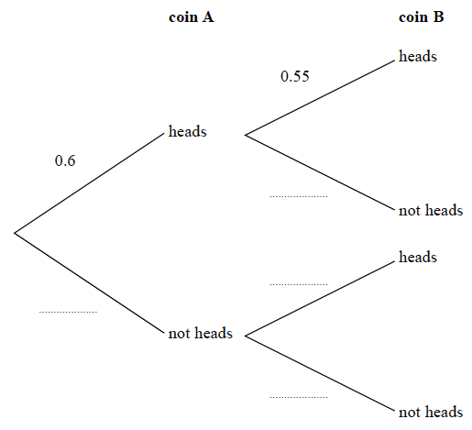
heads
heads
heads
tails
tails
tails
0.35
0.4
(2)

Tom throws coin A once and he throws coin B once.

(b) Work out the probability that both coins land on heads.

......................................................
(2)
(Total for Question 6 is 4 marks)

7 A paddling pool is in the shape of a cylinder.
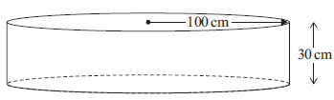
The pool has radius 100 cm.
The pool has depth 30 cm.

The pool is empty.
It is then filled with water at a rate of 250 cm³ per second.

Work out the number of minutes it takes to fill the pool completely.
Give your answer correct to the nearest minute.
You must show all your working.

...................................................... minutes
(Total for Question 7 is 4 marks)
___________________________________________________________________________

7 A paddling pool is in the shape of a cylinder.

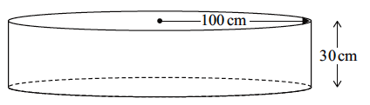
120 cm
40 cm

The pool has radius 120 cm.
The pool has depth 40 cm.

The pool is empty.
It is then filled with water at a rate of 320 cm³ per second.

Work out the number of minutes it takes to fill the pool completely.
Give your answer correct to the nearest minute.
You must show all your working.

...................................................... minutes
(Total for Question 7 is 4 marks)

8 a = $\left({3 \atop 2}\right)$ b = $\left({-1 \atop 4}\right)$

On the grid below, draw and label the vector 2a + b

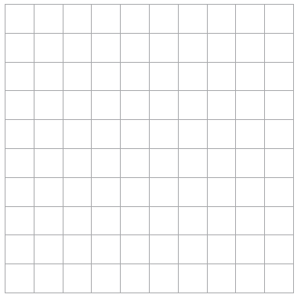

(Total for Question 8 is 3 marks)
___________________________________________________________________________

8 a = 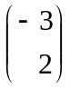 b = 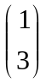

On the grid below, draw and label the vector 3a + b

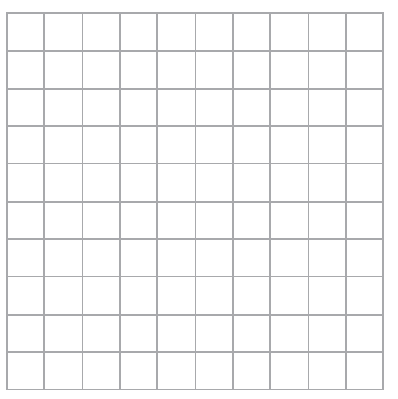

(Total for Question 8 is 3 marks)

9 The diagram shows a cube and a square-based pyramid.

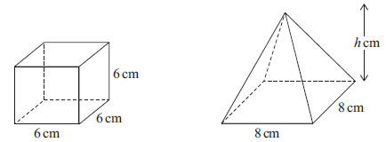

The volume of the cube is equal to the volume of the pyramid.

Work out the perpendicular height, h cm, of the pyramid.

...................................................... cm
(Total for Question 9 is 3 marks)
___________________________________________________________________________

9 The diagram shows a cube and a square-based pyramid.
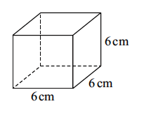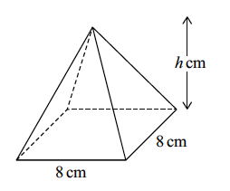
5 cm
5 cm
5 cm
5 cm
h cm
5 cm

The volume of the cube is equal to the volume of the pyramid.

Work out the perpendicular height, h cm, of the pyramid.

...................................................... cm
(Total for Question 9 is 3 marks)
___________________________________________________________________________
10 There are only red counters and yellow counters in bag A.
number of red counters : number of yellow counters = 3 : 5
There are only green counters and blue counters in bag B.
The number of counters in bag B is half the number of counters in bag A.
Given that there are x red counters in bag A,
use algebra to show that the total number of counters in bag A and bag B is 4x

(Total for Question 10 is 3 marks)
___________________________________________________________________________

10 There are only blue counters and orange counters in bag A.

number of blue counters : number of orange counters = 3 : 7

There are only pink counters and yellow counters in bag B.
The number of counters in bag B is half the number of counters in bag A.

Given that there are x blue counters in bag A,

use algebra to show that the total number of counters in bag A and bag B is 5x

(Total for Question 10 is 3 marks)
___________________________________________________________________________

11 Mina records the speeds, in mph, of some cars on a road on Friday.
She uses her results to work out the information in this table.

 | Speed (mph)
Lowest speed | 25
Lower quartile | 35
Median | 40
Interquartile range | 12
Range | 37

(a) On the grid, draw a box plot to show the information in the table.

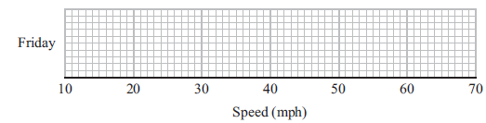
(3)
Mina also records the speeds of some cars on the same road on Sunday.
She uses her results to draw this box plot.
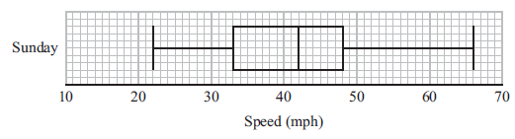
(b) Compare the distribution of the speeds on Friday with the distribution of the speeds
on Sunday.

......................................................................................................................................................

......................................................................................................................................................

......................................................................................................................................................

......................................................................................................................................................
(2)
(Total for Question 11 is 5 marks)
___________________________________________________________________________
11 Miranda records the speeds, in mph, of some lorries on a road on Friday.
She uses her results to work out the information in this table.

 | Speed (mph)
Lowest speed | 15
Lower quartile | 25
Median | 30
Interquartile range | 14
Range | 35

(a) On the grid, draw a box plot to show the information in the table.

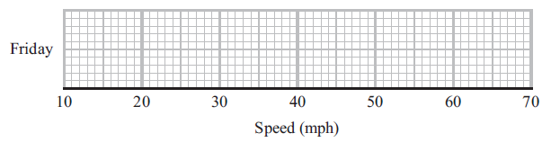
(3)

Miranda also records the speeds of some cars on the same road on Sunday.
She uses her results to draw this box plot.

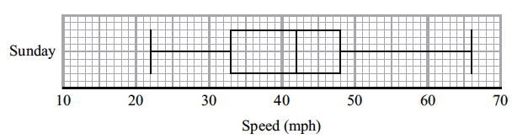

(b) Compare the distribution of the speeds of the lorries on Friday with the distribution of the speeds of the cars on Sunday.

...............................................................................................................................................

...............................................................................................................................................

...............................................................................................................................................

...............................................................................................................................................
(2)
(Total for Question 11 is 5 marks)

___________________________________________________________________________

12 The diagram shows triangle T drawn on a grid.

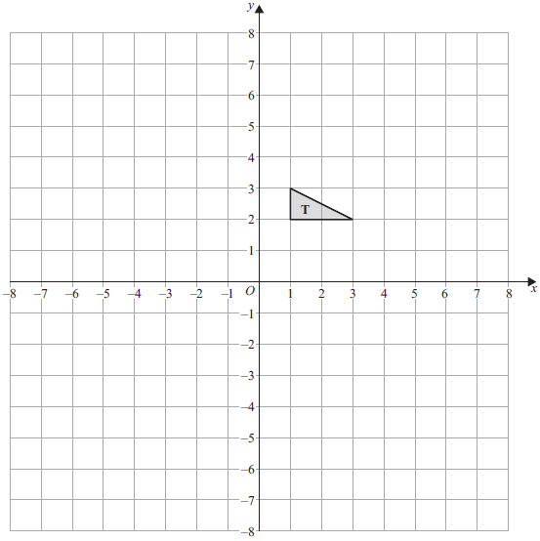

Enlarge triangle T by scale factor –2 with centre of enlargement (0, 0)

(Total for Question 12 is 2 marks)
___________________________________________________________________________

12 The diagram shows triangle T drawn on a grid.

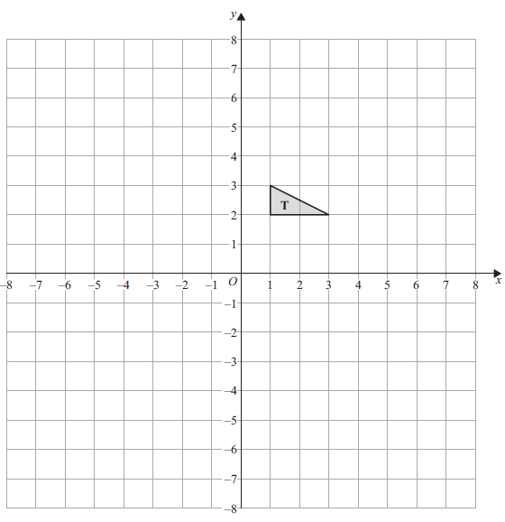

Enlarge triangle T by scale factor –2 with centre of enlargement (0, 1)

(Total for Question 12 is 2 marks)

13 There are 30 students in a class.
A teacher is going to choose at random 2 of the students.
Work out the number of different pairs of students that the teacher can choose.

......................................................
(Total for Question 13 is 2 marks)
___________________________________________________________________________

13 There are 22 players on a football pitch.
A coach is going to choose at random 2 of the players.

Work out the number of different pairs of players that the coach can choose.

......................................................
(Total for Question 13 is 2 marks)
___________________________________________________________________________

14 At the start of 2022 Kim invested some money in a savings account.
The account paid 3.5% compound interest each year.

At the end of 2022
interest was added to the account then Kim took £750 from the account.

At the end of 2023
interest was added to the account then Kim took £1000 from the account.

There was then £2937.14 in the account.

Work out how much money Kim invested at the start of 2022
You must show all your working.

£......................................................
(Total for Question 14 is 4 marks)
___________________________________________________________________________
14 At the start of 2022 Chloe invested some money in a savings account.
The account paid 4.5% compound interest each year.

At the end of 2022
interest was added to the account then Chloe took £850 from the account.

At the end of 2023
interest was added to the account then Chloe took £1500 from the account.

There was then £3727.09 in the account.

Work out how much money Chloe invested at the start of 2022
You must show all your working.

£......................................................
(Total for Question 14 is 4 marks)
___________________________________________________________________________

15 (a) Simplify fully $\frac{{\left(a-3\right)}^{2}}{5\left(a-3\right)}$

..................................................................................
(1)
(b) Factorise 3k² + 11k – 4

..................................................................................
(2)
(c) Simplify fully $\frac{4-x^{2}}{x^{2}+3x}÷\frac{x+2}{x+3}$

..................................................................................
(3)
(Total for Question 15 is 6 marks)
___________________________________________________________________________

15 (a) Simplify fully 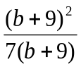

..................................................................................
(1)

(b) Factorise 3k² – k – 4

..................................................................................
(2)
(c) Simplify fully 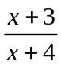 ÷ 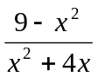

..................................................................................
(3)
(Total for Question 15 is 6 marks)

16 The functions f and g are given by

f($x$) = $\frac{12}{x+1}$ and g($x$) = 5 – 3$x$

(a) Find f(–3)

......................................................
(1)
(b) Find fg(1)

......................................................
(2)
(c) Find g^{–1}(4)

......................................................
(2)
(Total for Question 16 is 5 marks)
___________________________________________________________________________

16 The functions f and g are given by

f(x) = 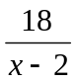 and g(x) = 6 – 2x

(a) Find f(–4)

......................................................
(1)

(b) Find fg(–1)

......................................................
(2)

(c) Find g^{–1}(10)

......................................................
(2)
(Total for Question 16 is 5 marks)
___________________________________________________________________________

17 A ball is thrown upwards and reaches a maximum height.
The ball then falls and bounces repeatedly.
After the nth bounce, the ball reaches a height of h_{n}
After the next bounce, the ball reaches a height given by h_{n + 1} = 0.55h_{n}
After the 1st bounce, the ball reaches a height of 8 metres.
What height does the ball reach after the 4th bounce?

...................................................... metres
(Total for Question 17 is 3 marks)
___________________________________________________________________________

17 A ball is thrown upwards and reaches a maximum height.
The ball then falls and bounces repeatedly.

After the nth bounce, the ball reaches a height of h_{n}
After the next bounce, the ball reaches a height given by h_{n + 1} = 0.45h_{n}

After the 1st bounce, the ball reaches a height of 6 metres.

What height does the ball reach after the 4th bounce?
Give your answer to 3 decimal places.

...................................................... metres
(Total for Question 17 is 3 marks)

18 ABCD is a quadrilateral.

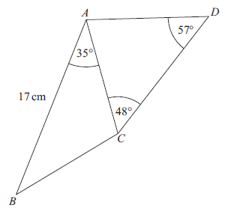

The area of triangle ABC is 54 cm²
Calculate the area of triangle ACD.
Give your answer correct to 3 significant figures.

...................................................... cm²
(Total for Question 18 is 5 marks)
___________________________________________________________________________

18 ABCD is a quadrilateral.
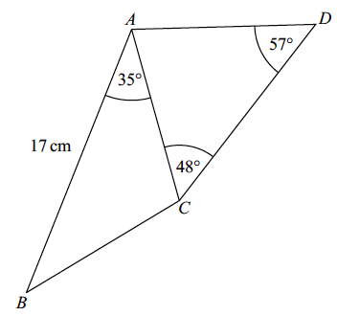
19 cm
31°
55°
42°

The area of triangle ABC is 75 cm²

Calculate the area of triangle ACD.
Give your answer correct to 3 significant figures.

...................................................... cm²
(Total for Question 18 is 5 marks)
___________________________________________________________________________

19 R = $\frac{P}{Q}$

$P$ = 5.88 × 10⁸ correct to 3 significant figures.
$Q$ = 3.6 × 10⁵ correct to 2 significant figures.

Work out the lower bound for R.
Give your answer as an ordinary number correct to the nearest integer.
You must show all your working.

..................................................................................
(Total for Question 19 is 3 marks)
___________________________________________________________________________

19 R = 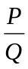

P = 5.88 × 10⁸ correct to 3 significant figures.
Q = 3.6 × 10⁵ correct to 2 significant figures.

Work out the upper bound for R.
Give your answer as an ordinary number correct to the nearest integer.
You must show all your working.

..................................................................................
(Total for Question 19 is 3 marks)
___________________________________________________________________________

20 x – 4, x + 2 and 3x + 1 are three consecutive terms of an arithmetic sequence.

(a) Find the value of x.

x = ......................................................
(2)
y – 4, y + 2 and 3y + 1 are three consecutive terms of a geometric sequence.
(b) Find the possible values of y.

......................................................
(5)
(Total for Question 20 is 7 marks)
___________________________________________________________________________

20 x – 3, x + 2 and 3x – 5 are three consecutive terms of an arithmetic sequence.

(a) Find the value of x.

x = ......................................................
(2)

3y + 1, y + 2 and y – 4 are three consecutive terms of a geometric sequence.

(b) Find the possible values of y.

......................................................
(5)
(Total for Question 20 is 7 marks)

21 The diagram shows a circle, radius r cm and two regular hexagons.
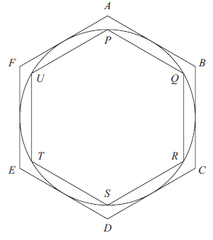
Each side of the larger hexagon ABCDEF is a tangent to the circle.
Each side of the smaller hexagon PQRSTU is a chord of the circle.
By considering perimeters, show that
$3$ < 𝜋 < $2\sqrt{3}$

(Total for Question 21 is 4 marks)

21 The diagram shows a circle, radius r cm and two regular hexagons.

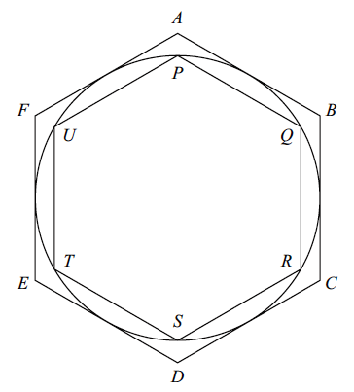

Each side of the larger hexagon ABCDEF is a tangent to the circle.
Each side of the smaller hexagon PQRSTU is a chord of the circle.

By considering areas, show that
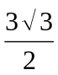 < π < 2√3

(Total for Question 21 is 4 marks)

___________________________________________________________________________
TOTAL FOR PAPER IS 80 MARKS

